KYRGYZ REPUBLIC

“Bishkekteploset”

Municipal Utility

Project Implementation Unit

“Bishkekteploset”

PROJECT

“Heat Supply Improvement Project”

Project Completion Report

Bishkek-2025

Table of content

ABBREVIATIONS AND ACRONYMS 3
Background 4
1. Brief information on the progress of implementation 7
2. Environmental and Social management 18
2.1 Brief description of the subproject 20
2.2 Grievance redress mechanism 22
Annex 1: Results Indicators 24
Annex 2. “Vostok” main heating network 25
Annex 3. Monitoring of construction works 26
Annex 4. Monitoring of IHSs installation 27
Annex 5. Certificate of completion of work 28
Annex 6. Photos of tree planting 29
Annex 7. E-log of grievances/appeals 1
Annex 8. Lessons learned 2

ABBREVIATIONS AND ACRONYMS

ARIS Community Development and Investment Agency
CA Cooperation Agreement
DDE Detailed design estimate
DED Design estimate documentation
DDI Due-diligence inspection
EA Environmental Assessment
EMM Environmental management measures
ESMP Environmental and Social Management Plan
FS Feasibility Study
GoKR Government of the Kyrgyz Republic
GRM Grievance redress mechanism
IDA International Development Association
KR Kyrgyz Republic
M&E Monitoring and evaluation
MU Municipal utility
MIS Management information system
NGO non-governmental organization
OM Operation manual
OP Operational policy
PIU Project implementation unit
RAP Resettlement Action Plan
SAACCS State agency for architecture, construction and housing services
SEA/SH Sexual exploitation and abuse/Sexual harassment
TS Technical supervision
UDP Urban Development Project
WB World Bank

Background

The objective of the HSIP project development is to improve the efficiency and quality of heating in the areas selected for the Project.
The development project was included in the Partnership Strategy between the Kyrgyz Republic and the World Bank for 2013-2017.
The project includes: (i) improving the efficiency and quality of the district heating system in Bishkek; (ii) testing efficient and environmentally friendly heating stoves; and (iii) demonstrating the benefits of improving energy efficiency in public buildings.
The total cost of the HSIP project as of September 17, 2025, is US$51.7 million, of which:
- Credit IDA 61460 – in amount of 22,4 mln. USD (indicated amount was withdrawn by “Bishkekteploset” MU).
- Grant IDA D2400 – in amount of 22,4 mln. USD. Of which:
- “Bishkekteploset” MU withdrew funds in the amount of 7,7 mln. USD;
- 9,7 mln. USD was withdrawn by ARIS; and
- The amount of 4,9 mln. USD was cancelled in ARIS part.
- Additional financing - credit (IDA 73740, the effectiveness date is March 6, 2024) – in amount of 6,9 USD. Of these, “Bishkekteploset” MU withdrew US$2.5 million through applications, and US$3.4 million was canceled on the basis of official letters under this credit.
The preparation of the Project was supported by a project preparation grant of US$0.39 million provided to the Government of the Kyrgyz Republic by the ECAPDEV, as well as by resources administered by the Bank under ESMAP and CAEWDP.
The main beneficiaries of the project were:
Component 1 (“Bishkekteploset” MU) - The main beneficiaries of improved efficiency of supply and quality of the heat supply system in Bishkek are residential, public, and commercial customers served by BTS. In addition, the BTS MU and the Bishkek City Hall will benefit from improved operational performance and related capacity-building activities supported under the Project;
Project components:
COMPONENT 1: Improving the efficiency and quality of the centralized heat supply system in Bishkek (estimated IDA funding: US$31 million).
This component financed capacity-building activities aimed at improving the efficiency and quality of the centralized heat supply system in Bishkek. The component will be implemented by BTS and consists of the following two subcomponents
Subcomponent 1.1: Priority investment program for the reconstruction of the Central Heating System. This subcomponent implemented priority investment programs for the Central Heating System managed by BTS, including related goods, works, and consulting services. Investment packages were selected based on a comprehensive technical and economic assessment of the system, using the following criteria to determine priorities: (i) impact on reducing heat and hot water losses, measured by economic rate of return; (ii) impact on the reliability and quality of supply, assessed on the basis of the technical condition of the district heating network (e.g., age and condition of assets, breakdown statistics, and number of connected customers). Accordingly, the two priority investment packages under subcomponent 1.1 included the following:
• Package 1: Modernization of individual heat substations (IHSs) at the building level. This package was implemented for: (i) installation of new IHSs in 221 residential multi-story buildings; (ii) repair and modernization of existing IHSs in 1825 multi-story buildings; (iii) 2 210 units of heat and hot water metering units at the building level with remote reading (“smart meters”); and (iv) installation of information system for preventive maintenance of heating stations.
• Package 2: Replacement and rehabilitation of “Vostok” main pipeline. This package was implemented for replacement, rerouting and reconstruction of 1,9 km (length of trench) of the most deteriorated sections of one of the five main pipelines (the Vostok main pipeline) with underground and over-ground pipes with factory insulation
The design, technical, and tender documentation for the selected investment packages was prepared as envisaged by the ECA Europe and Central Asia Region Capacity Development (ECAPDEV) and completed at the end of 2018. After that, BTS proceeded with the procurement of relevant goods and construction works in accordance with the agreed draft Procurement Plan.
Subcomponent 1.2: Strengthening operational capacity and supporting project implementation. This subcomponent financed activities aimed at strengthening the technical and operational capacity of the BTS, along with ensuring the effective implementation of the Project. Specific activities funded by the ECAPDEV preparation grant and IDA funds included the following: (i) Support the modernization of the BTS billing system to facilitate the transition to consumption-based billing and ensure proper revenue accounting; (ii) conducting information and awareness campaigns for households with the aim of transparently increasing customer support and improving understanding of planned investments; (iii) Provision of services for the evaluation of competitive bids submitted by Bidders; and (iv) providing support for project implementation, including strengthening the capacity of the project implementation unit (PIU) with qualified consultants on fiduciary issues and safeguards, conducting project monitoring and evaluation activities (e.g., customer satisfaction surveys), supporting project and entity audits by qualified firms acceptable to the World Bank, and covering additional project operating expenses.

1. Brief information on the progress of implementation

The financial agreement between the International Development Association (IDA) and the Government of the Kyrgyz Republic (GKR), represented by the Ministry of Finance of the Kyrgyz Republic (MoF), was signed on January 26, 2018.
Project Agreement (Heat Supply Improvement Project) between the International Development Association and Bishkekteploset Open Joint Stock Company, January 23, 2018.
Subsidiary (credit) agreement No. 19-04-01/16 dated April 17, 2019, between OJSC Bishkekteploset and the Ministry of Finance of the Kyrgyz Republic.
The Heat Supply Improvement Project came into force on April 25, 2019.
Component 1.1: The following activities were completed under this component:
- Delivery of 221 new individual heating units (IHSs) and spare parts and components for the overhaul of existing 1,825 IHSs for the city of Bishkek.
- 221 new IHSs were installed and 1825 IHSs were modernized.
- At the beginning of the project, the target of installation was was 1,931 units of IHSs (Project Appraisal document). However, according to the Inception report by the Consultant on the preparation of tender documentation for the “Modernization of individual heating substations and assistance in project implementation,” the recommended number was changed in accordance with technical specification of targeted installation addresses.. (The report of Ramboll consultant is attached in English and Russian.)
- Measures were taken to design, supply, and install heat and heat transfer meters with remote data collection and processing for 2,210 apartment buildings and public buildings. Metering units were actually installed at 2,197 addresses, or 4,344 meters. 2,210 buildings, and the target of 4,020 meters was conditionally accepted, assuming that there would be one meter for heating and one for hot water at each address. During the project, we kept track of the addresses and quantities. As a result, actually 4,344 meters or heat energy metering devices at 2,197 addresses were installed.
During the summary of the installation of metering units, it became clear that two houses had been demolished and the residents of eleven houses categorically refused to install new heat meters to replace their old ones. To avoid conflicts with residents, the company's technical council decided not to install the meters. These meters were recorded on the company's balance sheet as spare parts.
- The Vostok main network was reconstructed on the section from CK-B-3a to HC No. 4 (I, III, and IV start-up facilities), increasing the thermal energy capacity in the southern parts of Bishkek.
- The billing system was upgraded by renovating the server room and updating the server and computer equipment.
- Special equipment and machinery were delivered for the operational maintenance of main and in-house networks.
Component 1.2
- Billing system software was developed
- Bishkekteploset customer’s satisfaction survey was carried out
- Audit of Bishkekteploset Municipal utility
COMPONENT 1: Improving the efficiency and quality of the centralized heating system in Bishkek
Component 1.1:
Supply of individual heat substations (IHSs) and spare parts and components for overhaul of existing IHSs.
This procurement was conducted as a single lot.
Subproject | Lot No. | Contract commencement date | Contract completion date | Contractor | Contract price (EUR CIP/EUR DDP) | Total paid amount of contract price (KGS/USD) | Scope of completed works in accordance with payment made
Supply of individual heat substations (IHSs) and spare parts and components for overhaul of existing IHSs | 1 | 05.10.2021 | 31.03.2023 | AMARC DHS Srl и AMARC DHP Srl, (Италия) | 6,3 mln. EUR | 6,3 mln. EUR | 100

Challenges and problems in contract implementation
- Difficulties encountered in opening letters of credit by the banking sector of the Kyrgyz Republic and the European Union. Delays in the procedures for opening letters of credit had a negative impact on contract performance deadlines.
- The difficulties that have arisen in connection with the military conflict between Russia and Ukraine, which has affected the shipment of goods and the delivery of goods.
- Change in the legal status of the executive agency in connection with the merger of “Bishkekteploset” OJSC with “Electric Power Plants” OJSC. The process of reorganizing the energy system slowed down the implementation of planned work, as there were two reorganizations during the project.
The first was the transition to “Electric Power Plants” OJSC, which affected the speed of decision-making on various issues (all decisions had to be agreed upon with the entire management team). And second, according to the Decree of the President of the Kyrgyz Republic dated April 3, 2024, УП No. 89, the Cabinet of Ministers of the Kyrgyz Republic is instructed to reorganize the Ministry of Energy of the Kyrgyz Republic by dividing it and establishing state-owned enterprises. A decision has been made to transfer the heat supply facilities of the branches of “Electric Power Plants” OJSC: the combined heat and power plants in the cities of Bishkek and Osh, “Bishkekteploset” to the City Halls of Bishkek and Osh by establishing municipal heat supply enterprises on their basis for the subsequent transfer of the formed state-owned enterprises to the municipal property of local self-government bodies at their place of operation, which in turn led to a forced temporary suspension of the project.
Contractors also faced difficulties, as they had to re-sign bank guarantees and company details when issuing invoices.

Installation of 221 IHSs and modernization of 1825 IHSs
According to the project documents, this activity was planned to be carried out by “Bishkekteploset”, but given the limited time available for project implementation, a Contractor was employed for part of the IHSs modernization in agreement with the World Bank. “Bishkekteploset” MU installed 1,466 IHSs at its own expense. 580 IHSs were modernized by the Contractor.
The procurement was conducted in 2 lots.
Subproject | Lot No. | Contract commencement date | Contract completion date | Contractor | Contract price (KGS) | Total paid amount of the contract price (KGS) | Scope of completed works in accordance with payment made
Modernization of 300 individual heat substations (IHSs) in southern part of Bishkek | 1 | 29.04.2024 | 15.11.2024 | “CIC” LLC | 13 617 124,44 | 12 563 132,67 | 100
Modernization of 300 individual heat substations (IHSs) in south-western part of Bishkek. | 2 | 29.04.2024 | 15.11.2024 | “CIC” LLC | 13 617 124,44 | 13 308 494,79 | 100

Challenges and problems in contract implementation
- Lack of qualified contractors for the installation and modernization of IHSs. Announcements regarding this project were made three times.
- Long-term coordination of access to the property due to misunderstandings between the owners of apartment buildings.
Design, supply and installation of heat and hot water metering units with remote reading and information processing for 2210 apartment buildings and public buildings
The procurement was conducted in single lot.
Subproject | Lot No. | Contract commencement date | Contract completion date | Contractor | Contract price | Total paid amount of the contract price (EUR) | Scope of completed works in accordance with payment made
Design, supply and installation of heat and hot water metering units with remote reading and information processing | 1 | 05.10.2021 | 30.09.2025 | AMARC DHS Srl, (Italy) | 5,7 mln EUR | 5,6 mln. EUR | 100

Challenges and problems in contract implementation
- Difficulties encountered in opening letters of credit by the banking sector of the Kyrgyz Republic and the European Union. Delays in the procedures for opening letters of credit had a negative impact on contract performance deadlines.
- The difficulties that have arisen in connection with the military conflict between Russia and Ukraine, which has affected the shipment of goods and the delivery of goods.
- Change in the legal status of the executive agency in connection with the merger of “Bishkekteploset” OJSC with “Electric Power Plants” OJSC.
- Carrying out long-term modernization of IHSs. There were several factors affecting the timing of the IHS modernization, such as:
- the delayed tender process due to COVID-19;
- the military conflict between Ukraine and Russia, which led to a series of logistical problems that were resolved after changing the entire IHSs delivery route, which took more than six months.

Provision of consulting services for the evaluation of tender documentation for the modernization of individual heat substations and for the supply and installation of heat metering units
The procurement was carried out using the single-source method.
Subproject | Lot No. | Contract commencement date | Contract completion date | Contractor | Contract price (USD) | Total paid amount of the contract price (USD) | Scope of completed works in accordance with payment made
Consulting services for evaluating tender documentation for the modernization of individual heat substations and for the supply and installation of heat metering units | 1 | 02.06.2020 | 30.03.2021 | ELOMATIC OY (Finland) | 66 666,67 USD | 66 666,67 USD | 100

Reconstruction of “Vostok” main network, section from CK-B-3a to HC No. 4 (I, III and IV start-up facilities)
The procurement was conducted in three (3) lots
Subproject | Lot No. | Contract commencement date | Contract completion date | Contractor | Contract price (KGS) | Total paid amount of the contract price (KGS) | Scope of completed works in accordance with payment made
Reconstruction of “Vostok” main network, section from CK-B-3a to HC No. 4 (I, III and IV start-up facilities) | 1 | 6.03.2023 | 01.10.2023 | China Road and Bridge Corporation, Shandong Junhui Constraction Group Co. и ОсОО «Технотоп» | 203 633 091,11 | 196 493 084,05 | 100
 | 2 | 6.03.2023 | 01.10.2023 |  | 553 424 940,99 | 513 396 589,74 | 100
 | 3 | 6.03.2023 | 01.10.2024 |  | 550 607 251,45 | 469 536 022,54 | 100
In accordance with the schedule, work was completed on laying a main network with a total length of 1.9 km and a diameter of 900 mm in three pre-insulated pipelines. Installation of bellows compensators, installation of a leakage detection system.
In accordance with the technical specifications developed, under the daily supervision of technical engineers from the joint venture Urban Technology Alliance (UK/Ukraine) (leader), Inter Engineering Group (Kyrgyzstan) and Decon International GmbH (Germany), as well as representatives of “Bishkekteploset” MU, all construction and installation works were completed in full.
Provision of consulting services for reviewing cost estimates and evaluating bids for the Vostok main heating network
The procurement was carried out using the single-source method.
Subproject | Lot No. | Contract commencement date | Contract completion date | Contractor | Contract price (USD) | Total paid amount of the contract price (USD) | Scope of completed works in accordance with payment made
Consulting services for reviewing cost estimates and evaluating bids for Vostok main heating network | 1 | 23.03.2022 | 31.12.2022 | SEURECA (France) | 45 666,67 USD | 45 666,67 USD | 100

Provision of consulting services for design supervision of the construction of the Vostok main network, start-up facilities I, III, IV.
The procurement was carried out using the single-source method.
Subproject | Lot No. | Contract commencement date | Contract completion date | Contractor | Contract price (USD) | Total paid amount of the contract price (USD) | Scope of completed works in accordance with payment made
Consulting services for design supervision of the construction of the Vostok main network | 1 | 10.04.2023 | 31.12.2024 | SEURECA (Франция) | 36 111,11 USD | 36 111,11 USD | 100

Provision of consulting services for technical supervision of the construction of the Vostok main network, start-up facilities I, III, IV.
The procurement was carried out using a qualification-based selection method (CQS).
Subproject | Lot No. | Contract commencement date | Contract completion date | Contractor | Contract price (USD) | Total paid amount of the contract price (USD) | Scope of completed works in accordance with payment made
Consulting services for technical supervision of the construction of the Vostok main network консультационные услуги на технический надзор за строительством магистрального трубопровода «Восток» | 1 | 01.04.2023 | 31.12.2024 | Urban Technology and Aliance (England / Ukraine”-Inter Engineering Group (Kyrgyzstan) and Decon International GmbH (Germany) Association | 260 995,55 USD | 260 995,55 USD | 100

Supply of special equipment
The procurement was carried out in eleven (11) lots.
Subproject | Lot No. | Contract commencement date | Contract completion date | Contractor | Contract price (KGS) | Total paid amount of the contract price (KGS) | Scope of completed works in accordance with payment made
Procurement of special equipment | 1 | 22.04.2025 | 21.04.2025 | “Sota Group” LLC | 675 840,00 | 675 840,00 | 100
Procurement of special equipment | 2 | 22.04.2025 | 21.04.2025 | “Sota Group” LLC | 915 200,00 | 915 200,00 | 100
Procurement of special equipment | 3 | 25.04.2025 | 24.04.2025 | “Iz ruk v ruki” LLC | 320 060,00 | 320 060,00 | 100
Procurement of special equipment | 4 | 25.04.2025 | 24.04.2025 | “Iz ruk v ruki” LLC | 138 060,00 | 138 060,00 | 100
Procurement of special equipment | 5 | 22.04.2025 | 21.04.2025 | “Sota Group” LLC | 124 608,00 | 124 608,00 | 100
Procurement of special equipment | 6 | 22.04.2025 | 21.04.2025 | “Sota Group” LLC | 166 144,00 | 166 144,00 | 100
Procurement of special equipment | 7 | 18.04.2025 | 17.06.2025 | “Rusad” LLC | 608 100,00 | 608 100,00 | 100
Procurement of special equipment | 8 | 25.04.2025 | 24.04.2025 | “Iz ruk v ruki” LLC | 312 390,00 | 312 390,00 | 100
Procurement of special equipment | 9 | 22.04.2025 | 21.04.2025 | “Sota Group” LLC | 1 557 600,00 | 1 557 600,00 | 100
Procurement of special equipment | 10 | 22.04.2025 | 21.04.2025 | “Sota Group” LLC | 1 163 008,00 | 1 163 008,00 | 100
Procurement of special equipment | 11 | 18.04.2025 | 17.06.2025 | “Rusad” LLC | 188 500,00 | 188 500,00 | 100

The procurement was carried out using funds saved from the project for repair work on the building and main networks of MU Bishkekteploset. The following equipment was procured as part of this activity:
- Pumps 35 m³/h
- Leak detector (digital)
- Pump with a capacity of up to 100 m³ per hour
- Diesel asphalt cutter
- Hand-held pneumatic rammer
- Diamond drilling machine with attachments
- Concrete cutter
- 6,5 kW Mobile generator
- 50 kW generator on a wheeled base
- Plasmacutter included (compressor generator)
- Fan with air duct

Supply of special machinery
The procurement was carried out in seven (7) lots.
Subproject | Lot No. | Contract commencement date | Contract completion date | Contractor | Contract price (KGS) | Total paid amount of the contract price (KGS) | Scope of completed works in accordance with payment made
Procurement of special machinery | 1 | 25.06.2025 |  | «KBS group» LLC | 8 045 000,00 | 7 843 875,00 | 201 125,00 penalties (100%)
Procurement of special machinery | 2 | 25.06.2025 |  | «KBS group» LLC | 15 360 000,00 | 15 360 000,00 | 100%
Procurement of special machinery | 3 | 30.06.2025 |  | «DT Technik» LLC | 35 105 000,00 | 34 692 000,00 | 99% difference due to penalties related to the delivery
Procurement of special machinery | 4 | 30.06.2025 |  | “Virazh” LLC | 4 889 400,00 | 2 444 700,00 | Balance is payment for Dump Truck (Acceptance certificate signing is awaited)
Procurement of special machinery | 5 | 30.06.2025 |  | “Virazh” LLC | 12 460 000,00 | 12 460 000,00 | 100%
Procurement of special machinery | 6 | 25.06.2025 |  | «KBS group» LLC | 2 045 000,00 | 0,00 | Acceptance certificate signing is awaited
Procurement of special machinery | 7 | 24.06.2025 |  | “Shaturniy” PE | 7 124 598,00 | 7 124 598,00 | 100%
- KBS group LLC - We are awaiting the signing of the acceptance certificate, after which payment will be made. The Supplier has already provided a bank guarantee.
- Virazh LLC - The acceptance certificate has been signed by all parties (for all lots). We are awaiting a bank guarantee from the Supplier for the warranty period. Payment will be made after the bank guarantee is provided.
The procurement was carried out using funds saved from the project for repair work on the building and main networks of MU Bishkekteploset. The following special machinery was procured as part of this activity:
- Cargo manipulator (with a crane capacity of 6-7 tons) - 2 units.
- Large excavator (rotary, wheeled) - 2 units.
- Passenger and cargo vehicle (team van) - 7 units.
- Dump truck with a load capacity of at least 10 tons. - 2 units.
- Passenger and cargo vehicle with double cab and flatbed - 7 units.
- Trench remote vibratory roller - 1 units.
- Welding machine – 6 units.

Supply and installation of server equipment

The procurement was carried out in nine (9) lots.
Subproject | Lot No. | Contract commencement date | Contract completion date | Contractor | Contract price (KGS) | Total paid amount of the contract price (KGS) | Scope of completed works in accordance with payment made
Supply and installation of server equipment | 1 | 18.06.2025 |  | Leader Technology LLC | 4 446 232,00 | 0,00 | The equipment will not be delivered.
Supply and installation of server equipment | 2 | 18.06.2025 |  | ProInt LLC | 129 280,00 | 129 280,00 | 100
Supply and installation of server equipment | 3 | 18.06.2025 |  | Leader Technology LLC | 10 100,00 | 10 100,00 | 100
Supply and installation of server equipment | 4 | 18.06.2025 |  | ProInt LLC | 9 650,00 | 9 650,00 | 100
Supply and installation of server equipment | 5 | 18.06.2025 |  | Leader Technology LLC | 129 200,00 | 129 200,00 | 100
Supply and installation of server equipment | 6 | 18.06.2025 |  | Leader Technology LLC | 109 600,00 | 109 600,00 | 100
Supply and installation of server equipment | 8 | 18.06.2025 |  | Leader Technology LLC | 297 200,00 | 297 200,00 | 100
Supply and installation of server equipment | 9 | 18.06.2025 |  | ProInt LLC | 46 000,00 | 46 000,00 | 100
- Leader Technology LLC, Lot 1 - We are expecting delivery of server equipment and software. If the goods arrive after October 31, 2025, payment for this Lot will not be made.

The project provided for the modernization of the server equipment of “Bishkekteploset” MU to modernize the billing system. As part of this activity, the following equipment was procured:
Lot No. | Description of goods | Qty.
1 | Server station with licensed software | 2
2 | Server cabinet | 2
3 | Server network filter and КVM - switch | 2
4 | Network equipment (for connecting network switches between buildings at a distance of up to 500 m, at a speed of 10 Gb/s) | 1 set
5 | Data storage system (NAS) | 1
6 | Uninterruptable power supply (UPS) for server | 2
8 | Complete computer | 10
9 | Uninterruptable power supply for computer | 10

Complete renovation of the premises with full engineering systems to create a data center (DC)

This procurement was carried out in one (1) lot.
Subproject | Lot No. | Contract commencement date | Contract completion date | Contractor | Contract price (KGS) | Total paid amount of the contract price (KGS) | Scope of completed works in accordance with payment made
Complete renovation of the premises with full engineering systems to create a data center (DC) | 1 | 13.06.2025 | 20.09.2025 | “Akrakom” LLC | 3 015 920,62 | 3 015 920,62 | 100%
- Akrakom LLC - Final acceptance certificate is under signing. Final payment will be made within two to three days.
The following types of work were carried out to ensure the servers functioned properly:
- Dismantling works
- Installation works (renovation of premises, ventilation system)
- Electrical installation work (air conditioning system, alarm and video surveillance system, fire extinguishing system)
- Commissioning works
Consultant for upgrade of billing system

The procurement was carried out using the single-source method.
Subproject | Lot No. | Contract commencement date | Contract completion date | Contractor | Contract price (KGS) | Total paid amount of the contract price (KGS) | Scope of completed works in accordance with payment made
Consultant for upgrade of billing system | 1 | 01.10.2022 | 31.10.2024 | Nurtozhoev A. | 2 375 000,00 | 2 375 000,00 | 100

As part of this task, the billing system was upgraded to take into account data received from heat metering units for the purpose of providing bills for heat consumption to customers of the Bishkekteploset municipal utility. Given the changes in Kyrgyz Republic legislation on heat metering and tariffs, this system is constantly updated with the ongoing support of a consultant.

Component 1.2
Customer’s satisfaction survey (baseline)
The procurement was carried out using a qualification-based selection method (CQS).

Conducting a Customer’s satisfaction survey among customers of the “Bishkekteploset” municipal utility

The procurement was carried out using the single-source method.
Subproject | Lot No. | Contract commencement date | Contract completion date | Contractor | Contract price (KGS) | Total paid amount of the contract price (KGS) | Scope of completed works in accordance with payment made
Customer’s satisfaction survey (baseline) | 1 | 18.09.2020 | 18.0001.2021 | “AC Consulting LLC | 2 338 159,79 | 2 338 159,79 | 100
“Bishkekteploset” Customer’s satisfaction survey | 1 | 23.04.2025 | 24.07.2025 | “AC Consulting LLC | 2 367 040,00 | 2 367 040,00 | 100

As part of this task, the survey was carried out, which consisted of collecting and analyzing data to determine/diagnose the level of customer/consumer satisfaction with the services of “BTS” MU.
Assessing beneficiaries through customer satisfaction surveys provided insight into whether customers were satisfied with the service, which aspects needed improvement, and identified direct ways to increase satisfaction.
Key information was collected at the very beginning so that conclusions could later be drawn about the quality and results achieved during the project implementation.
The customer satisfaction survey served two purposes: to assess the level of customer satisfaction (perception) with the quality of district heating services and satisfaction with the interaction of BTS MU staff (controllers, customer service center employees, etc.) with customers. To this end, the survey included quantitative and qualitative research methods.

Audit of enterprise
The procurement was carried out using the lowest cost selection method. (LCS)

Audit of enterprise
The procurement was carried out using a single-source method.

Subproject | Lot No. | Contract commencement date | Contract completion date | Contractor | Contract price (USD) | Total paid amount of the contract price (USD) | Scope of completed works in accordance with payment made
Audit of enterprise | 1 | 09.01.2020 | 01.07.2023 | “BDO Armenia” CJSC | 214 358,60 USD | 214 358,60 USD | 100
Audit of enterprise | 1 | 18.12.2023 | 30.04.2024 | “BDO Armenia” CJSC | 119 441,77 USD | 119 441,77 USD | 100

The auditor's services include conducting an external audit of financial statements prepared in accordance with International Financial Reporting Standards (IFRS) and in accordance with the Credit Agreement between the Kyrgyz Republic and the World Bank.

2. Environmental and Social management
The HSIP project is categorized as Category B for both anticipated environmental and social impacts based on the type, location, scope, sensitivity, nature and degree of potential adverse environmental and social impacts.
In accordance with World Bank procedures, the Resettlement Policy Framework (RPF) , Environmental and Social Management Framework (ESMF), Environmental and Social Management Plan (ESMP), Grievance Redress Mechanism (GRM) ) and GRM for Project staff, Social Due Diligence (SDD), and Tree Inventory Report.
The RPF identifies key areas for developing appropriate mitigation measures, including compensation for mitigation and compensation for damage caused by land acquisition and resettlement resulting from planned project activities. The RPFs will be used as a tool to determine whether there will be an impact as a result of the project activities and have been developed as a practical tool for preparing Resettlement Action Plans (RAPs), if applicable, during the implementation of the HSIP.
RPF defines procedures and measures to prevent negative impacts on the natural and social environment. The RPF underwent public consultations and was approved by the World Bank, ARIS, and BTS. Compliance with and implementation of the RPF is mandatory for all Project participants.
For each component of the subproject "Replacement and reconstruction of the Vostok main heating network section, I, III, and IV start-up facilities“ (subproject ‘Vostok’) within Component 1 ”Improving the reliability of heat supply and the performance of the centralized heat supply system," ESMPs were developed, which describe specific types of work and the location of components in accordance with the requirements of the RPF.
The ESMP, developed for each start-up facility within the framework of the Vostok subproject, is a mandatory document that shall be complied with during the implementation of the project and is included in the Contractor's contract.
The ESMP consists of a set of mitigation, monitoring, and institutional responsibility measures that will be undertaken during the implementation and operation of facilities to eliminate negative environmental and social impacts, compensate for them, or reduce them to an acceptable level.
Public consultations on the ESMP were held on November 19, 2020. Due to restrictions imposed because of the COVID-19 pandemic, public consultations were held remotely, online via WhatsApp. The participants included representatives of local authorities, businesses located along the main network lines, BTS management and employees, as well as BTS PIU specialists.
Since the ESMP for each section (I, III, and IV) was prepared in 2020, all ESMPs were updated based on the results of the re-screening and SDD conducted at the end of 2022, and public consultations on the ESMPs updates took place on April 25, 2023. A total of 32 people participated. Comprehensive and detailed information was provided on the project, the approximate start and completion dates of construction, potential impacts and measures to minimize and/or mitigate impacts, OP 4.12 requirements, and GRM.
All work was carried out only after obtaining the necessary permits and approvals. Prior to the start of construction work, the public, local construction supervision and environmental protection inspectorates were provided with full information about the upcoming activities via social media, letters, notices posted on the sites (including at the work sites), and through public consultations on the ESMP.
The contractor implemented safety measures at the construction site to protect workers and the public, including providing PPE for workers and installing signs warning the public about potential safety risks at and around construction sites.
Dust formation was properly monitored at the construction site. The contractor took measures to prevent dust formation by regularly watering the construction site and roads.
All objects dismantled by the Contractor as a result of construction work on this subproject have been restored by the Contractor to their original condition. This includes asphalt pavement and curbs.
The Project has an GRM and GRM for Project employees, which have been developed in accordance with the Law of the Kyrgyz Republic “On the Procedure for Considering Citizens' Appeals,” as well as the requirements of the procedures for implementing projects financed by the World Bank and the internal regulations of the “BTS” MU.
For public access to information, the GRMs developed are posted on the BTS website. The contractor developed its own GRM and familiarized its employees with it.
Information banners were installed/displayed at the work sites, indicating the contact details of the BTS and the Contractor for the functioning of the GRM.
An electronic logbook for grievances and appeals has been developed as part of the GRM. In turn, the Contractor has a logbook for recording grievances and appeals in the foreman's field office.
The SDD report has been prepared to determine the project's impact on forced resettlement (if any) for the application of mitigation measures and to ensure that all necessary actions and procedures are carried out in accordance with the requirements of OP 4.12 and in accordance with the legislation of the Kyrgyz Republic.
The results of the conducted SDD of “Vostok” subproject revealed that the application of OP 4.12 “Involuntary Resettlement” is not expected.
The tree inventory report has been prepared to conduct an inventory/registration of the species, sizes, and condition of trees in the construction right-of-way, assess the expected impact of the proposed reconstruction, and provide more detailed information to help preserve trees during project implementation.

2.1 Brief description of the subproject

Type of activity: Reconstruction
Types of planned activities within the subproject: “Replacement and reconstruction of the Vostok main network section. Start-up facilities I, III, and IV”

Design and estimate documentation (DED) for subproject was prepared by “Seureca” company. DED was approved by the Chui-Bishkek Territorial Department of the State Agency for Environmental Protection and Forestry under the Government of the Kyrgyz Republic on November 21, 2018 and by the Department of State Expertise under the State Agency for Architecture, Construction, Housing and Communal Services under the Government of the Kyrgyz Republic on July 23, 2020. DED was revised and approved in 2022 due to rising prices for building materials which was approved by the extended meeting of the General Directorate of EPP OJSC "Bishkekteploset" on April 22, 2022. No technical changes related to location, length and right of way of the network planned have been made.
The length and diameter of pipelines to be installed by sections of the Subproject “Vostok” are given in Table 1 below.

Table 1. Length of start-up facilities to be reconstructed

№ | Name of start-up facility | Location | Length | Diameter of pipelines, mm
 |  |  |  | Existing | To be installed
1 | Ist start-up facility  (works were completed in 2023) | СК-В-3а to СК-В-4 | 330 m | 2 Dn 700 mm | 2 Dn 900 mm
2 | IIIrd start-up facility  (works were completed in 2023) | Thermal chamber to СК-В-9  Thermal chamber CK-B-9 to thermal chamber CK-B-8 | 814 m | 2 Dn 700 mm  2 Dn 700 mm | 3 Dn 900 mm  2 Dn 200 mm  (over ground pipeline)
3 | IV start-up facility  (works were completed in 2024) | СК-В-9 to НС 4 | 760 m | 2 Dn 700 mm | 2 Dn 900 mm
 | TOTAL |  | 1904 m

Reconstruction work on sections I and III was completed in 2023, and on section IV in October 2024. All work was carried out in compliance with all measures specified in the ESMP. The contractor had a designated person responsible for compliance with the ESMP. Information banners were displayed at construction sites with details about the subproject, including its name, the duration of planned works, and contact details for the GRM. Portable pedestrian bridges were installed, signs were put up, etc. Continuous environmental and social monitoring was carried out by BTS PIU and the technical supervision company Consortium "UTA, Decon International & Inter Engineering Group Consortium (technical supervision company), which involves regular monitoring of all physical work carried out by contractors and, accordingly, control over compliance with the requirements of the ESMP, which includes all measures to reduce and/or minimize impacts.
At the beginning there was discussion of reconstructing all four start-up facilities of the Vostok main network, with a total length of 3,326 m. Due to the long domestic procedures, it was decided to begin reconstruction of the second start-up facility (1,000 m long) using funds from the Russian-Kyrgyz Development Fund. This decision was also made because the road above the second start-up facility was to be reconstructed in accordance with the Master Plan for the city of Bishkek.
Subsequently, the reconstruction structure was modified, and the actual length of the reconstruction was 1,904 m.
During the construction work, minor comments were made, which the contractor addressed in a timely manner.
“BTS” MU, concluded a contract with “Amarc” LLC (subcontractors - ‘Ekson’ LLC and “Engineer Montazh” LLC) for “Design, supply, installation and commissioning of 2210 heat and hot water s metering units with remote data reading and processing for individual heat substations in apartment buildings”. The contract includes preparation of design for installation of heat and hot water metering units with remote data reading and processing, delivery of equipment and materials, installation of heat and hot water metering units with remote data reading and processing, commissioning, software installation, equipment commissioning and training. Commencement date - 05.10.2022, completion date - 30.09.2025.

Table 2. Installation of metering units

No. | Name of Sub-contractor | Installed/ units
1 | “Ekson” LLC | 1105
2 | “Engineer Montazh” LLC | 1105
 | Total | 2210

Contractors carry out measures aimed at ensuring employee safety and preventing accidents. This includes complying with instructions, using personal protective equipment, conducting briefings, monitoring workplace conditions, and responding to accidents and emergencies.
In place of the uprooted trees, on October 21, 2025, the contractor (Consortium “China Road and Bridge Corporation”, “Shandong Junhui Constraction Group Co.” and “Technotop” LLC) prepared tree planting sites and planted 55 trees at the IVth start-up facility. A Certificate of Completion of Work for the tree planting was drawn up and signed (Annex 5). The contractor planted birch trees at this site (Annex 6).

2.2 Grievance redress mechanism

In accordance with the Law of the Kyrgyz Republic “On the Procedure for Considering Citizens' Appeals” and the requirements of World Bank policies, GRM has been developed for Component 1 “Improving the reliability of heat supply and the productivity of the central heating system” for the HSIP.
The prepared GRM was approved on March 28, 2023, GRM for project employees – on February 28, 2024 and published on the “BTS” MU website for public access to information.

The purpose of the GRM is to record and address any grievances that may arise during the project implementation phase and/or any future operational issues that could potentially be resolved during the implementation phase. The GRM aims to resolve concerns and grievances quickly and transparently without any consequences (in terms of cost, discrimination) based on any communications made by project-affected persons
The GRM operates within existing legal and cultural frameworks, providing an additional opportunity for grievance resolution at the local level – the Project level.

The GRM for the HSIP is managed by the PIU. Grievances and appeals can be expressed at any time during project implementation.
There is no fee for submitting a grievance, appeal, comment or suggestion.

Citizens/beneficiaries/project affected parties can submit grievances and appeals related to the project-financed activities through following channels:

1) Appeals of citizens can be transferred during receptions of citizens by the management of BTS according to the reception schedule.
2) Oral or written grievances against project personnel (directly or through project meetings). If project stakeholders submit verbal feedback/grievance, project staff will submit a complaint on their behalf and will be handled through the same channels.
3) Mail boxes, located in “Bishkekteploset”, address: 2/1 Zhukeeva-Pudovkina st., Bishkek
4) Letters are to be sent to the address: /1 Zhukeeva-Pudovkina st., Bishkek, PIU/WB
5) E-mail: piu@teploseti.kg
6) Tel.: (0312) 61-11-69, (0557) 61-11-66, (0777) 61-11-66, (0701) 61-11-66
7) Web-site “BTS” PIU: www.teploseti.kg

The project should provide flexibility in the channels available, make sure that the addressee has different contacts to submit a verbal grievance, and grievances addressed to the wrong person or organization will be forwarded to the GRM responsible.

If the applicant is satisfied with the answer, discussions will be held in a group or individually to further clarify the positions. These meetings will be attended by senior management and the final decision on the action(s) will be made.

A total of 3 complaints were received. All complaints have been resolved (Annex 7).

There were no accidents during the works implementation.

Information on complaints and their status was regularly sent to the World Bank.

Sensitive grievances redress

In line with the standards for preventing sexual exploitation and abuse/sexual harassment (SEA/SH), which are required by the World Bank, all project staff will be informed about the principles of controlling and preventing SEA/SH risks at all stages of project implementation. GRM will ensure access to and confidentiality of the grievance redress mechanism and will allow the Applicant to feel safe from retaliation. SEA/SH issues require additional measures:

- The GRM will be accessible and ensure the confidentiality of personal information;
- Information and awareness-raising activities will be conducted to inform the public about the GRM, including sensitive grievances;
- The GRM coordinator for SEA/SH issues, if any, will be appointed by the BTS PIU and communicated to local residents in the project area, as well as to the Contractor's employees;
- The GRM confidentiality principle will be included in the sub-project ESMPs and duplicated in all information materials.
3. Lessons learned
Holding regular awareness-raising meetings for all stakeholders;
Regular monitoring of contractors' compliance with the requirements set out in the ESMPs;
Holding training seminars on the World Bank's ESS for contractors.

Annex 1: Results Indicators

Indicator name | Baseline  (2017) |  | Actual (current = October, 2025) | End target (=project closure October, 2025) | Remark
1 Number of individual substations installed/rehabilitated (cumulated) (number) | 0 |  | - 2,046 | 1,931 | According to the contract No.: IDA-HSIP-ICB-HHMU/1-2020 dtd. October 5 2021.
2 Number of installed heat and hot water meters (cumulative) (number) | 0 |  | 4,344. | 4,020
3. Length of DH pipeline installed (m) | 0 |  | - 1904 m | 1,870 | Vostok main network was divided into several sections, part of them (1000 m) was reconstructed by means of other credit funds (RKDF).  - Start-up facility I – 330 m actual  - Start-up facility III – 814 m actual  Start-up facility IV – 745 m planned, 760 m actual
4. Projected lifetime energy savings (MW/h) | 0 |  | 2 381 301 | 2,168.5
5. Projected lifetime CO2 savings (t/year) | 0 |  | 890,368 | 777,081
6. Direct project beneficiaries (number) | 0 |  | 142,982 | 150,148 | Measurement unit: customer/user connected to network
7. Female beneficiaries (percent) | 0 |  | 55 | 50 | Reference to statistics data of residents of Bishkek city as of 01.01.2025
8. Projected lifetime fuel savings (MJ) | 0 |  | 8 572 683 840 | 7,871,875,994
9. Percent of project beneficiaries. reporting an improvement in the quality of heating (%) | 0 |  | 0 | 70

Due to the fact that the main heat generator, the Bishkek CHP plant, is unable to increase the volume of heat energy produced for heating and hot water, the planned volume of new customers connected was not achieved, and therefore the indicator did not reach its target values.

Annex 2. “Vostok” main heating network
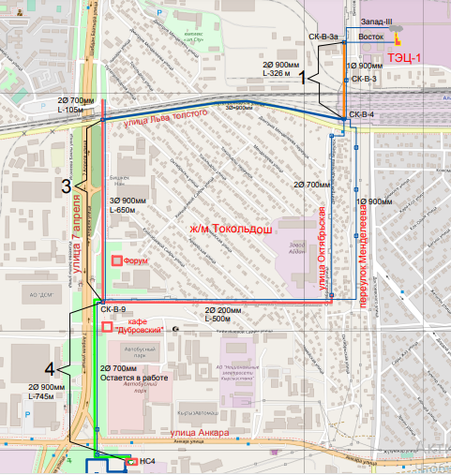

Annex 3. Monitoring of construction works

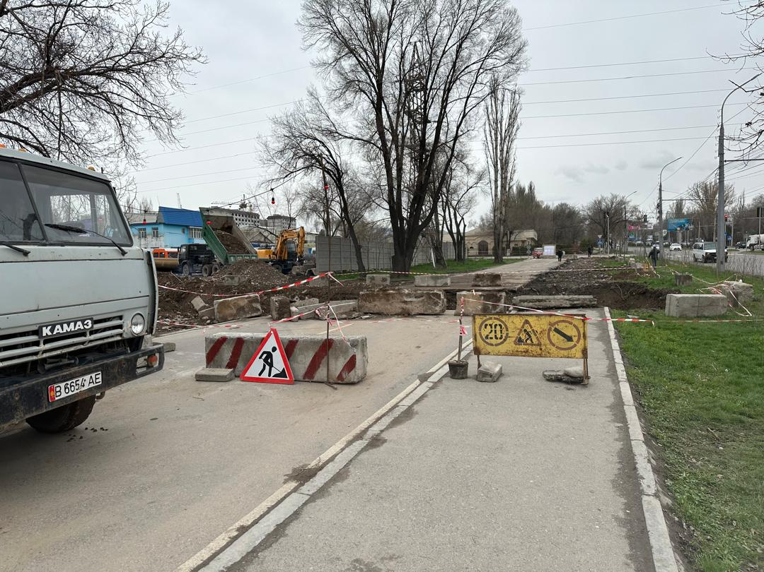
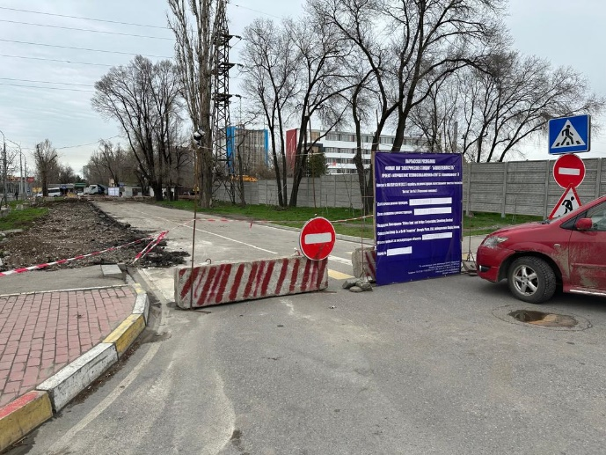
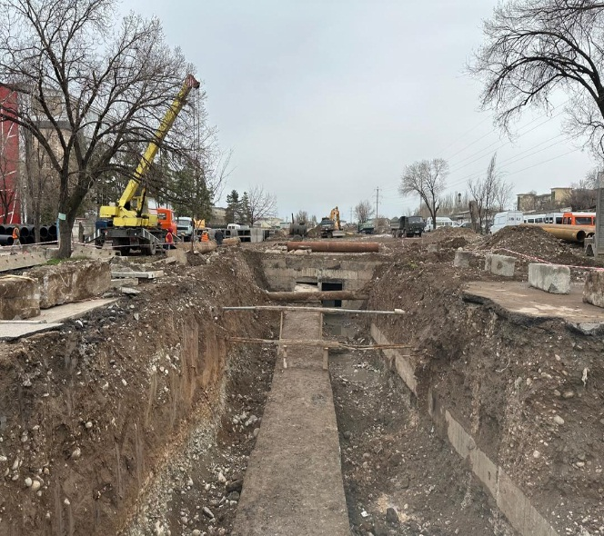
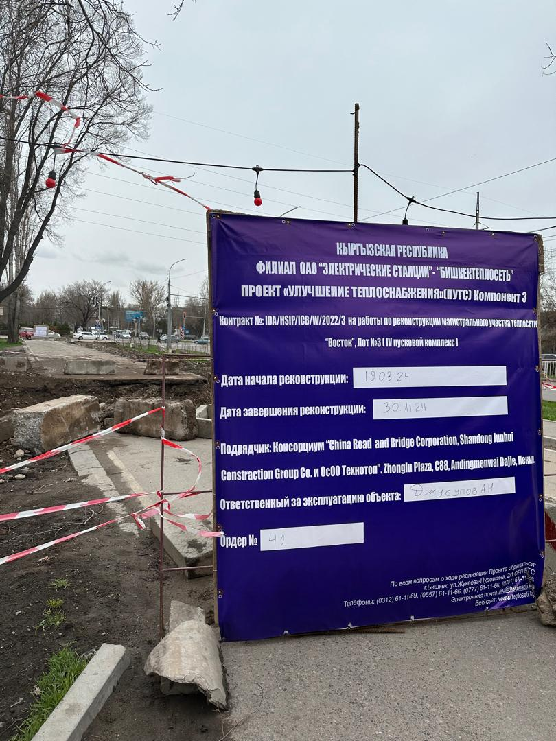
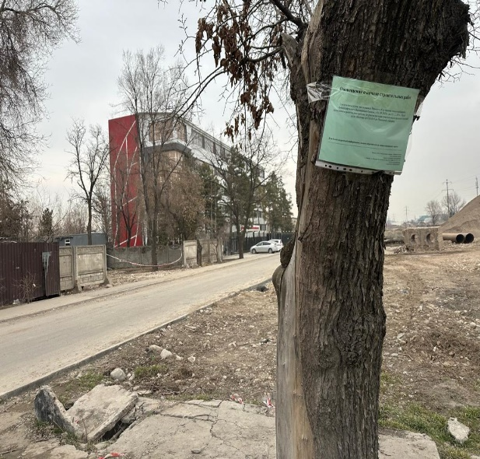
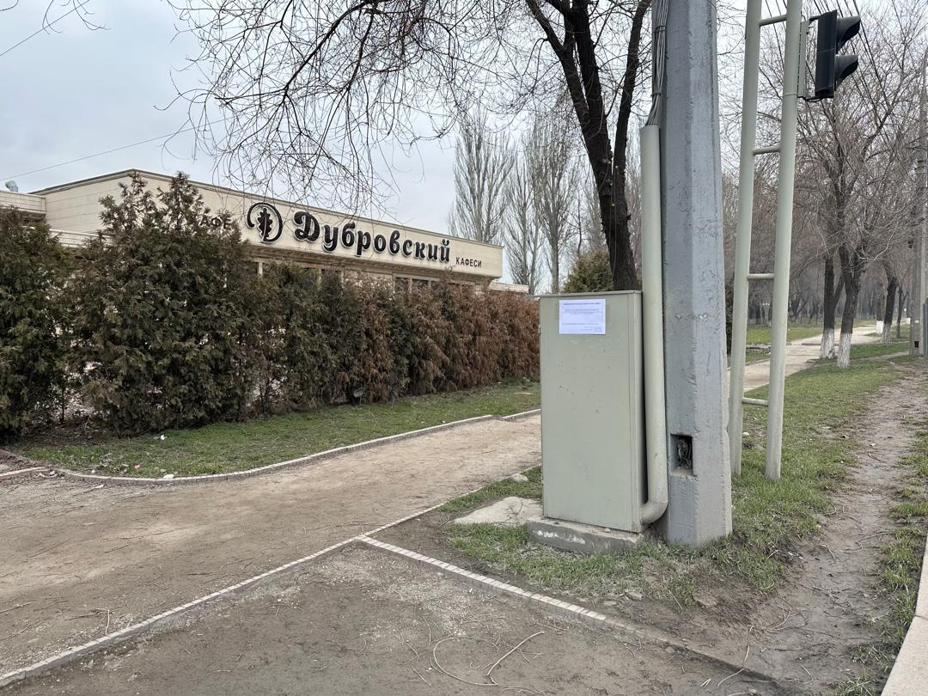

Annex 4. Monitoring of IHSs installation
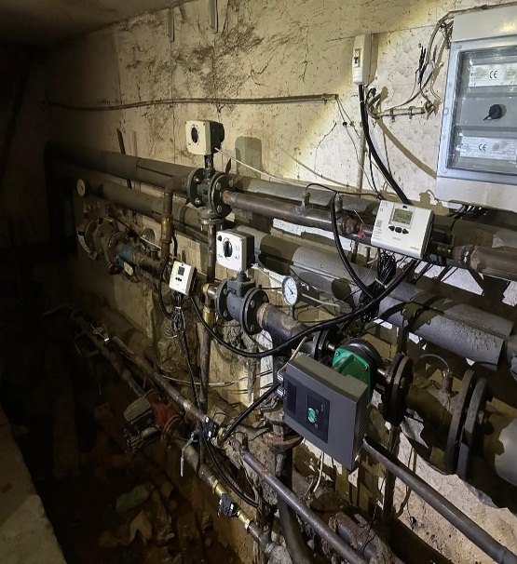
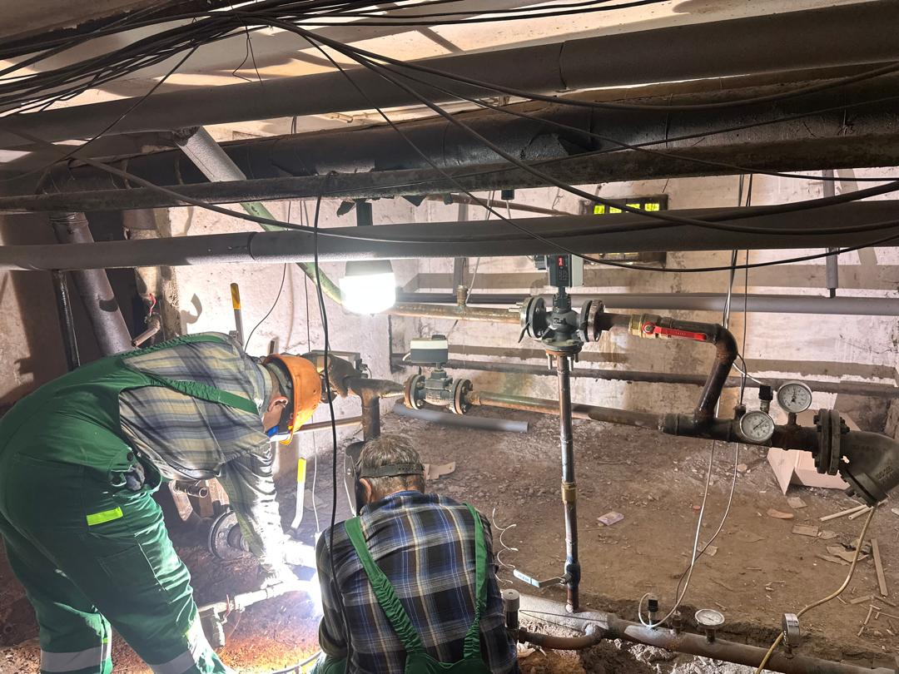
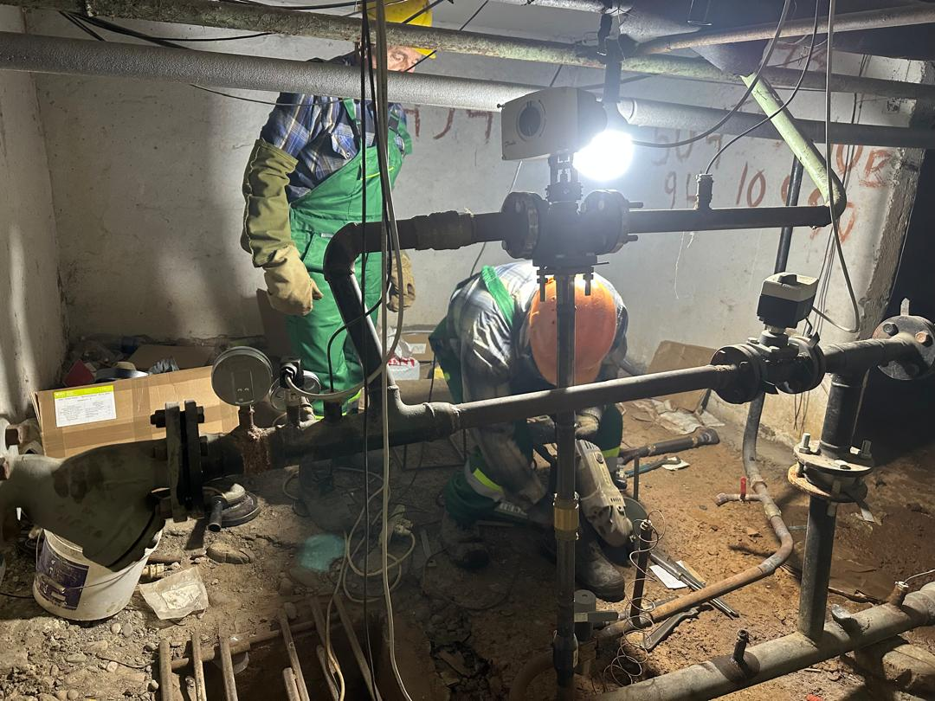
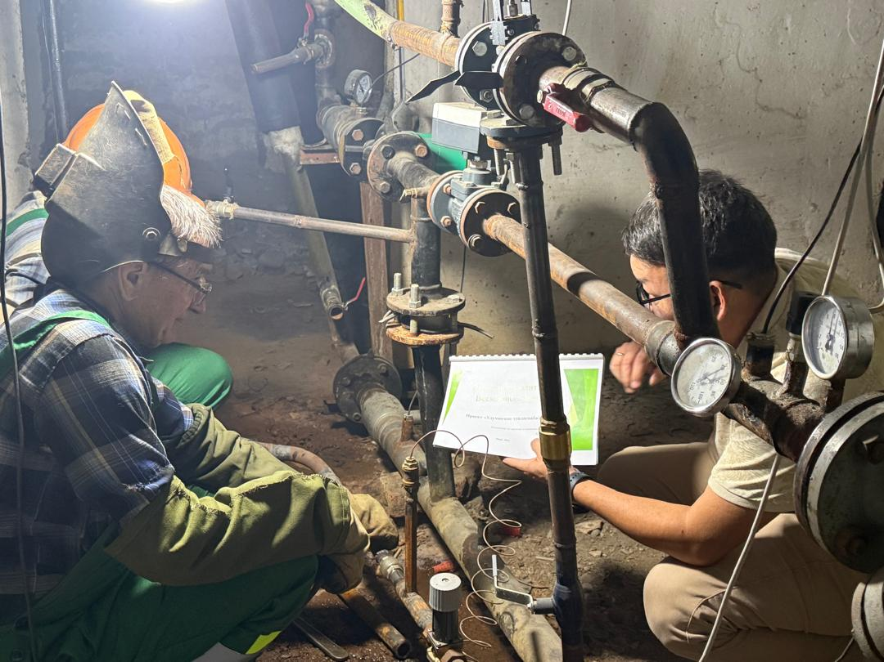
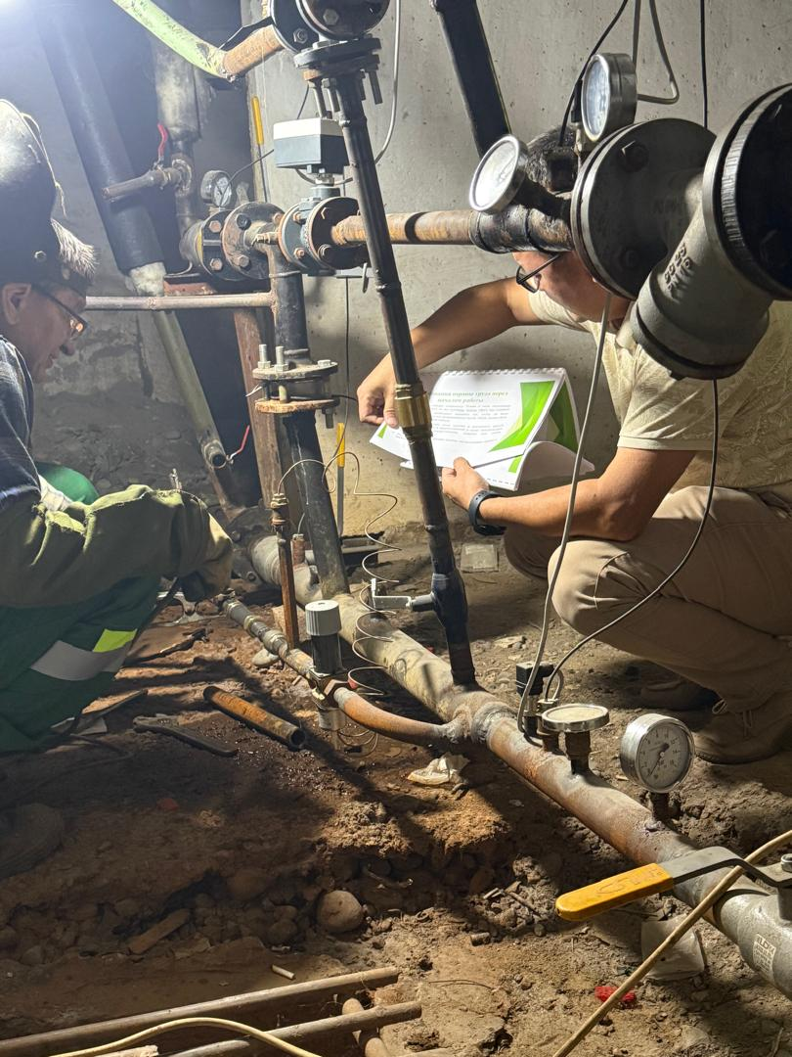
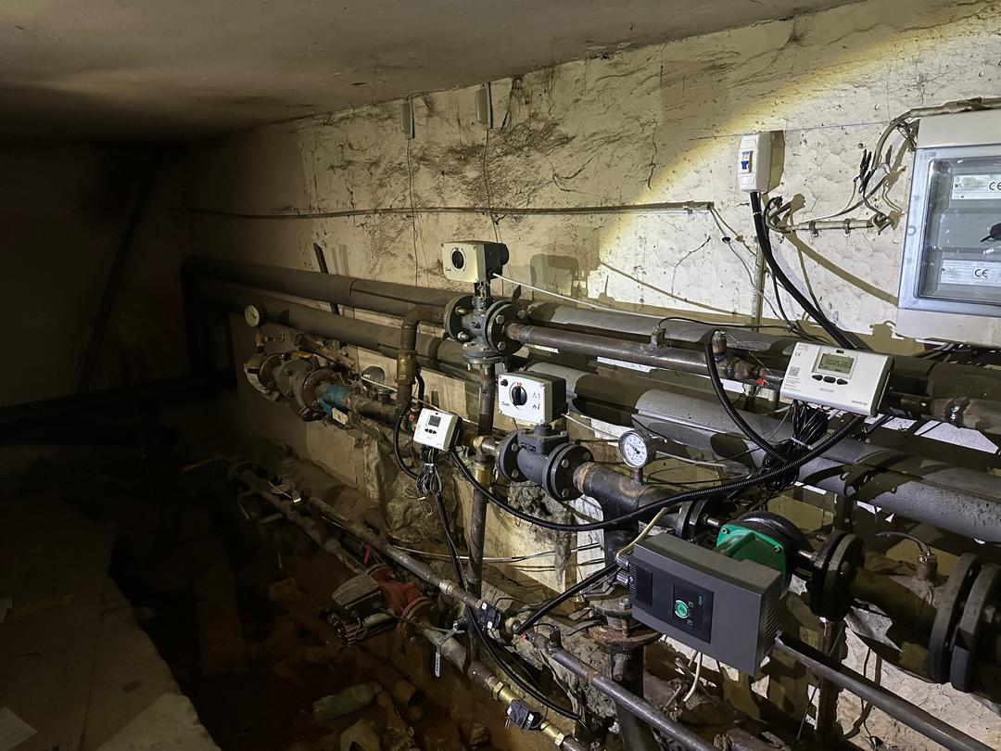

Annex 5. Certificate of completion of work

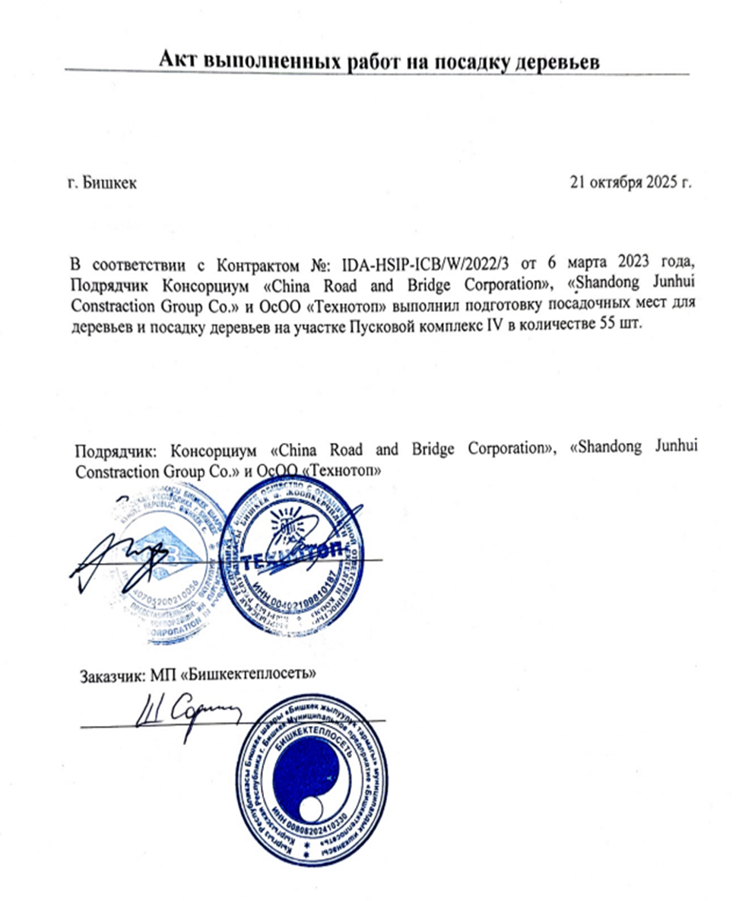

Annex 6. Photos of tree planting

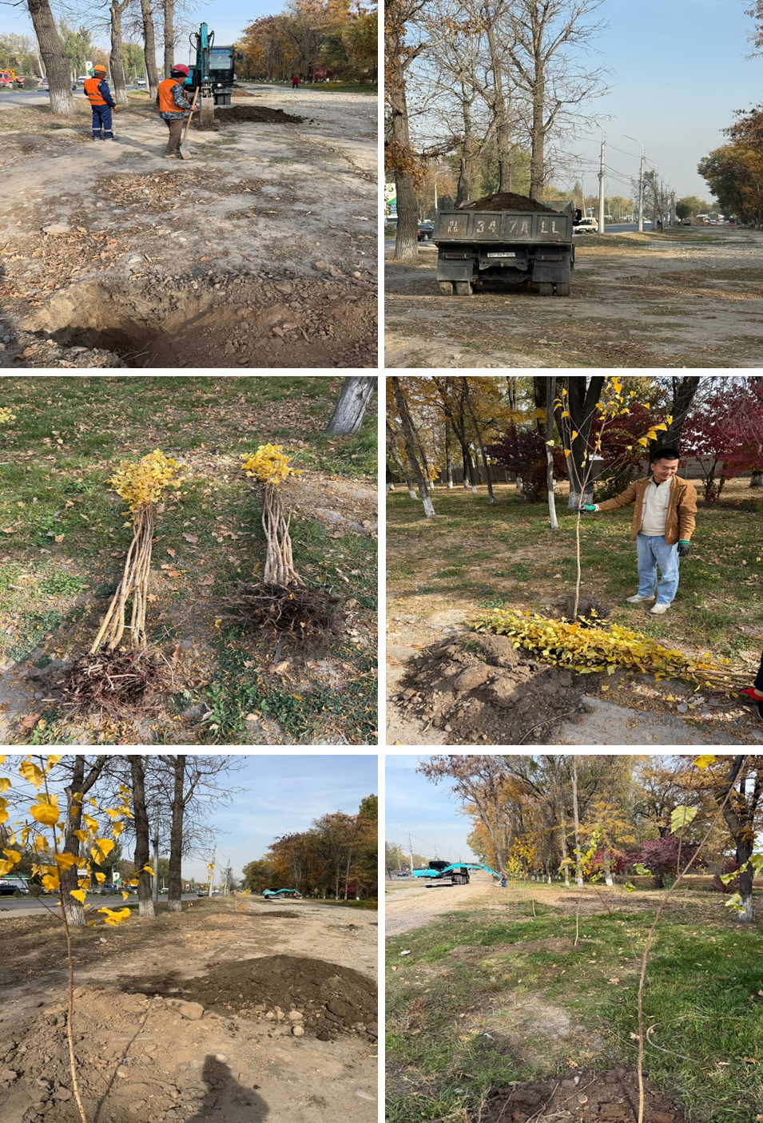

Annex 7. E-log of grievances/appeals

№ | Date of grievance/appeal receipt/registration | Category (by classification) | Grievance/appeal content | Method of grievance/appeal submission | Name of Applicant | Sex | Contact information (address/tel.No./e-mail | Grievance/appeal resolution progress | Responsible for feedback | Date of feedback and publication on web-site | Confirming doc.
1. | 05.07.2021 | Category 8 | 1.Disagreement with the results of the tender  Supply of new IHSs and spare parts and accessories for overhaul of HIS; 2. Design, supply and installation of heat and hot water metering units with remote reading and information processing | 4th channel | Kvon N.G. | Male | 148, Kurmanzhan Datka st., Bishkek  Tel. No. +996 312 36 4310  e-mail: dir-cic@mail.ru | Written feedback was provided.  The grievance is resolved. | BTS PIU Senior Procurement specialist/ Sharshekeev N. | 14.08.2021 | Letter No. 219/1569-21 dtd. 14.08.2021
2 | 01.06.2023 | Category 8 | Access to education institution | 4th channel | Savchenko E.Yu. | Female | 17A/1 L/ Tolstoy st., Bishkek  Tel. No.: +996 312 64 23 37; e-mail: info@muk.iuk.kg | Written feedback was provided.  The grievance is resolved. | BTS PIU Senior Procurement specialist/ Sharshekeev N. | 21.07.2023 | Letter dtd 21.07.2023
3 | 29.07.2024 | Category 9 | The content of grievance is to install heat and hot water metering unit in multistorey building before heating period starts | 4th channel | Collective grievance | Female | 61, Ibraimov st., Bishkek  e-mail: elnura-1@yandex.com | Written feedback was provided.  The grievance is resolved. | BTS PIU Engineer/ Zhalieva A. | 08.08.2024 | Letter No. 01-2/156 dtd. 08.08.2024

Annex 8. Lessons learned

During the implementation of the project, valuable practical knowledge and management skills were acquired that can be used in similar projects in the future. The main lessons learned and experiences gained include the following:

A comprehensive approach to the modernization of heating networks

The modernization of the heating main network demonstrated that planning and precise coordination between contractors, designers, and operating departments are key factors for the successful completion of work on time and with minimal risk to customers. Experience was also gained in carrying out work in dense urban areas and taking into account the existing infrastructure.

Features of IHSs implementation in residential buildings

The installation of new individual heating substations (IHSs) and the modernization of existing ones have allowed to accumulate knowledge in terms of the technical integration of new equipment into existing systems. In particular, a coordination scheme with management companies and residents was developed, and issues related to minimizing inconvenience to residents during the work were resolved.

Accuracy of accounting and improvement of energy efficiency

Experience in installing heat and hot water meters has confirmed the importance of selecting and configuring the right equipment. During implementation, typical design errors were identified and eliminated, which will improve metering accuracy and reduce resource losses in the future. In addition, the installation of meters encourages customers to take a more responsible approach to energy consumption.

Organization of design, construction, and installation works

The project provided practical experience in organizing construction and installation works in compliance with schedules and regulatory requirements. Particular attention was paid to safety, occupational health, and quality control issues at all stages of implementation.

Stakeholders engagement

One of the important aspects achieved within the framework of the project was the improvement of skills in engagement of various stakeholders, from local authorities to residents. Well-established information support and transparency of processes made it possible to increase the level of trust in the project.

http://teploseti.kg/content/articles_view/895
http://teploseti.kg/content/articles_view/895
http://www.teploseti.kg/content/page/76
http://www.teploseti.kg/content/page/76
http://www.teploseti.kg/content/page/76
http://www.teploseti.kg/content/page/76
http://www.teploseti.kg/content/page/76

