THE KYRGYZ REPUBLIC

“Bishkekteploset” Municipal Enterprise

Project Implementation Unit
“Bishkekteploset”
Project
“Heat supply improvement project”
Project Semi-Annual Report on Socio-Environmental Compliance for January-June, 2025

Component 1: Improvement of heat supply reliability and efficiency of the district heating system
Sub-project: “Replacement and reconstruction of section of “Vostok” main network, Start-up Facilities I, III and IV

Environmental and Social Consultant
Zhumaliev K.

Bishkek, 2025
Table of content
ABBREVIATIONS 3
Background 4
1. Description of the subproject 5
2. WB policies and procedures on safeguarding measures 7
3. Grievance redress mechanism 9
4. Monitoring and reporting 11
5. Conclusion and recommendations 11
Annex 1. General Layout of “Vostok” network 13
Annex 2. Facilities recovered by the Contractor 14
Annex 3. Letter of Guarantee 15
Annex 4. Training 16

ABBREVIATIONS

ARIS Community Development and Investment Agency
“BTS” ME “Bishkekteploset” Municipal Enterprise
CP Condensate pipeline
DED Design and estimate documentation
Dn Nominal diameter
EIZ Eastern Industrial Zone
ESMP Environmental and Social Management Plan
GRM Grievance redress mechanism
IUK International University of Kyrgyzstan
OP Operational policy
PIU Project Implementation Unit
PS (НС) Pump Station
PPU Foam polyurethane
RN Return network
SEA/SH Sexual exploitation, abuse/sexual harassment
SDD Social due diligence
SN Supply network
SNiP Construction norms and rules
SP Steam pipeline
TC (TK) Thermal chamber
WB World Bank

Background
Heat supply improvement Project (HSIP) in the Kyrgyz Republic (KR) financed by the World Bank aims to improve effectiveness and quality of heat supply in the project target areas.

(1) improving the reliability and efficiency of the district heating system (DHS) in Bishkek,
(2) improving energy efficiency of public buildings.

Direct Executors of the HSIP are “Bishkekteploset” ME for component 1 and the Community Development and Investment Agency (ARIS) for component 2.

The implementation of the HSIP will have a favourable impact on the proposed project facilities by improving the efficiency and quality of heat supply for heating and hot water supply.

Implementation of the HSIP Project will have positive environmental and social impacts and favourable impacts on the proposed project sites, improving the efficiency and quality of heat supply for heating and hot water purposes. Under component 1, Environmental and Social Management Plans (ESMPs), Grievance Redress Mechanism (GRM), Grievance Redress Mechanism for PIU staff, Subproject Social Due Diligence Report (SDDR), Tree Inventory Report have been prepared to manage social risks. All prepared documents have been published on the website and distributed to stakeholders.
This report summarizes the status of construction works, information disclosure, awareness and adherence to the ESMP, GRM, SDDR, Code of Conduct by the personnel of the Contractor: Consortium “China Road and Bridge Corporation”, “Shandong Junhui Constraction Group Co.” and “Technotop” LLC (Contractor) and “Amarc” LLC.

The HSIP is expected to have positive social impacts on a wide range of stakeholders and beneficiaries including: residential, public and commercial customers who will directly benefit from the modernization of sections of the main heat network.
The following environmental impacts are expected: noise, soil and water impact due to construction activities, vehicle traffic restrictions during construction and rehabilitation activities, construction dust and debris, and worker safety. However, these adverse impacts will be temporary and dependent on the construction site. And they can be freely mitigated by implementing appropriate prevention and/or mitigation measures.

Negative impacts on the natural environment, protected areas, historical and cultural heritage sites are not expected as the project will be implemented in an urban area.

There may be a risk to the safety and health of workers and the public during works and during operational phase. However, it should be noted that these risks will be reduced through proper management and implementation of the works.

1. Description of the subproject
Component 1: Improvement of reliability of heat supply and effectiveness of the District Heating system
Executive agency: OJSC “Electric Power Plants”
Place of project implementation: Bishkek city
Period of construction works implementation: 2023
Type of activity: reconstruction
Types of planned activities under the subproject: "Replacement and reconstruction of section of “Vostok” main heat network. I, III, and IV start-up facilities"

Design and estimate documentation (DED) for subproject was prepared by “Seureca” company. DED was approved by the Chui-Bishkek Territorial Department of the State Agency for Environmental Protection and Forestry under the Government of the Kyrgyz Republic on November 21, 2018 and by the Department of State Expertise under the State Agency for Architecture, Construction, Housing and Communal Services under the Government of the Kyrgyz Republic on July 23, 2020. DED was revised and approved in 2022 due to rising prices for building materials which was approved by the extended meeting of the General Directorate of “EPP” OJSC - "Bishkekteploset" on April 22, 2022. No technical changes related to location, length and right of way of the network planned have been made.
The length and diameter of pipelines to be installed by sections of the Subproject “Vostok” are given in Table 1 below.

Table 1. Length of reconstructed start-up facilities

№ | Name of start-up facility | Location | Length | Diameter of pipelines, mm
 |  |  |  | Existing | To be installed
1 | Ist start-up facility (works were completed in 2023) | СК-В-3а to СК-В-4 | 330 m | 2 Dn 700 mm | 2 Dn 900 mm
2 | IIIrd start-up facility (works were completed in 2023) | Thermal chamber to СК-В-9 | 814 m | 2 Dn 700 mm | 3 Dn 900 mm
3 | IVth start-up facility (works were completed in 2024) | СК-В-9 to НС 4 | 760 m | 2 Dn 700 mm | 2 Dn 900 mm
 | TOTAL |  | 1 904 m

IVth start-up facility

Works on reconstruction of the section of the main heating network "Vostok" were carried out from CK-B-9 (approximate landmark – 7th April street, turn to the building of the International University of Kyrgyzstan) to pump station HC-4 (approximate landmark - pump station).

The reconstruction commencement date is March, 2024, reconstruction completion date – October 2024. Length of the route is 760 m.

The contracting company, based on its capabilities, developed the site in parts. Route of IVth start-up facility including previously completed sections I and III can be found in Annex 1.

The reconstruction of CK-B-9 (approximate landmark - 7 April Street, the turn to the building of the International University of Kyrgyzstan) and then from CK-B -9 to the south to CK-B-13 underground pipeline of the heating network of 2Dn-900mm in polyurethane foam insulation in reinforced concrete trays is installed.

From CK-B-13 a respective transfer existing pipelines of 2Dn-700 mm to one 1 Dn-900mm being designed was performed.
From CK-B-13 to CK-B-14 the pipelines of 2Dn-900 mm and 1Dn900 mm by 3Dn900 mm in polyurethane foam insulation in reinforced concrete trays were installed.

The reconstruction of CK-B-14 with installation of sectioning valves 2 Dn900 mm in it with transfer in 1Dn1000mm (Supply system) pipeline and 1 valve of Dn900 mm on pipeline of Dn900mm (Return system) with the following re-laying of existing pipelines from CK-B-14 to HC №4 (approximate landmark – pump station) with 1 Dn1000 mm and 1Dn900 mm in reinforced concrete trays was performed.

In CK-B-9а, CK-B-11, CK-B-13 and CK-B -14 existing consumers were switched to reconstructed heating network.
Metering units were installed in pavilions between CK-B-13 and CK-B-14 without narrowing the pipeline diameter. The length of route is 760 m.

As per SNiP IV – 5 – 82 p. IV sec. 5 this heating main line was constructed in confined conditions (7th April street with the intersection of streets and crossings) and was characterized by the presence of three main factors: density of automobile transport traffic in the immediate vicinity of the work site; extensive network of existing underground networks, presence of high-voltage lines to be suspended or relocated; as well as preserved green plants in the immediate vicinity of the work site.

The reconstruction works on section IV were completed in October 2024. All reconstruction works were carried out in compliance with all measures prescribed in the ESMP. There was a responsible person on the contractor's side who was responsible for compliance with the ESMP. Information banners with subproject information, including subproject name, duration of planned works and GRM with contact details were displayed at the construction sites, portable pedestrian bridges were installed, signs were put up, etc. Ongoing environmental and social monitoring was carried out by the Project Implementation Unit (PIU) and the technical supervision company Consortium UTA, Decon International & Inter Engineering Group, which involves regular monitoring of all physical works carried out by the contractors and consequently monitoring compliance with the ESMP requirements, which includes all mitigation and/or minimization measures.

Minor remarks were made during the construction works which the contractor eliminated in a timely manner.

“BTS” ME, concluded a contract with “Amarc” LLC (subcontractors - ‘Ekson’ LLC and “Engineer Montazh” LLC) for “Design, supply, installation and commissioning of 2210 heat and hot water s metering units with remote data reading and processing for individual heat substations in apartment buildings”. The contract includes preparation of design for installation of heat and hot water metering units with remote data reading and processing, delivery of equipment and materials, installation of heat and hot water metering units with remote data reading and processing, commissioning, software installation, equipment commissioning and training. Commencement date - 05.10.2022, completion date - 30.09.2025.

Table 2. Installation of metering units

No. | Name of Sub-contractor | Planned to be installed/ units | Installed/ units
1 | “Ekson” LLC | 1105 | 900
2 | “Engineer Montazh” LLC | 1105 | 929
 | Total | 2210 | 1829

2. WB policies and procedures on safeguarding measures

The PIU with the technical supervision company and the contractor employed for implementation of this subproject made every effort to ensure that the subproject is implemented in accordance with national legislation and WB environmental and social policy requirements, including implementation of the following mitigating measures:

The ten safeguard policies as well as Policy +1 "Access to Information" present a set of safeguard mechanisms applied by the WB in the interests of beneficiaries, clients, stakeholders and the WB. Their application allows avoiding negative impacts on the environment and human life, minimizing and/or mitigating potentially adverse environmental and social impacts of project activities.
The HSIP project is categorized as Category B for both anticipated environmental and social impacts based on the type, location, scope, sensitivity, nature and degree of potential adverse environmental and social impacts.

After the work was done, the contractor restored everything and brought everything to its original condition as stated in the ESMP (Annex 2):

Gazprom Neft Asia Gas station
- The asphalt pavement has been restored;
- Lawn was temporarily relocated and then restored to its old location;
- Curbs have been reinstated;
- Drip irrigation system was temporarily removed and then installed after construction works.

“Dasmia” café
- Spruce plantings were temporarily relocated without damaging the roots and then re-planted on the old site;
- The foundation was restored;
- Fencing was temporarily removed, then reinstalled at the old location;
- Asphalt pavement has been restored;
- The lightweight structure (metal slide) was temporarily dismantled and installed after the construction works were completed.

To replace the uprooted trees, the contractor plans to plant 55 saplings. Due to climatic requirements, planting will be done in the fall of 2025. There is a letter of guarantee from the contractor (Annex 3).

Before the start of works, trainings on compliance with social and environmental requirements of the WB, as well as trainings on safety during works were conducted for subcontractors Ekson LLC and Engineer Montazh LLC involved in installation of metering units. Total number of participants - 16 (Annex 4).

In order to comply with the WB Policy, all prepared and updated documents as well as annual/semi-annual reports are published on the website of the “BTS” ME.

Notification of the commencement of the upcoming works. Prior to the start of reconstruction works, entrepreneurs and local communities and the objects located in the reconstruction areas were notified about the works to be carried out through official letters, existing communication channels (project website, social networks, official letters, etc.).

Health and safety of local residents. Risks to health and safety of local residents during the reconstruction and operation phases were mitigated by “BTS” ME by taking appropriate measures. In addition to the above notice of commencement of works, information banners with subproject information, including project name, duration of the planned works and GRM with contact details were placed at the construction site by the contractor. Easy-to-read warning signs, including signs warning of hazards (e.g. moving machinery) were prominently displayed in risk areas.

Access to homes/facilities. Particular attention was paid to ensuring unobstructed access to homes and business facilities such as: shops, warehouses, office buildings, gas station and “Dasmia” Café for delivery of goods, access of residents/workers/customers to these homes and/or facilities. All mitigation measures were strictly followed to ensure that there are no both permanent and temporary impacts on access to houses and/or properties along the reconstructed network.

Uninterrupted road traffic and free movement of people. The works were organized in such a way as to ensure uninterrupted road traffic and free movement of people. The public, including businesses and people living in the immediate vicinity of the works, as well as drivers, were informed of the temporary traffic closure several days in advance (via the project website, social media, information boards at the sites, through the media, etc.) to minimize impacts. Appropriate visual traffic safety signs were installed and displayed at all times, especially when temporary alternative route changes are necessary. These included temporary footbridges, paths, speed limits, parking spaces, etc.

Informing the local population about the interruption of engineering networks. During network relocation, water, electricity, telecommunication and internet services may be disrupted for a short period of time. In order to minimize impacts, entrepreneurs and people living in the immediate vicinity of the works were provided with the date and time of interruption of engineering network several days in advance (via the project website, social media, information boards at the sites, media, etc.).
Local authorities and relevant services were also informed.

Restoration of land, asphalt road, fences and other facilities affected by construction activities. All facilities dismantled by the Contractor as a result of construction activities under this subproject were restored to their original condition by the Contractor.

Tree planting. Trees may be uprooted. After construction works, it is planned to plant saplings on the place of uprooted trees at the rate of 3 to 1.

Relocation of engineering networks. The Contractor is responsible for the restoration and regular dissemination of information related to the relocation of associated networks, both municipal and private.

3. Grievance redress mechanism

The GRM was approved on March 28, 2023, GRM for PIU staff was approved on March 28, 2024, and published on the “BTS” ME website for public access to information. The purpose of the GRM is to record and address any grievances that may arise during the project implementation phase and/or any future operational issues that could potentially be resolved during the implementation phase. The GRM aims to resolve concerns and grievances quickly and transparently without any consequences (in terms of cost, discrimination) based on any communications made by project-affected persons.

Project beneficiaries affected by the project (directly or indirectly, positively or negatively) as well as other citizens can use the GRM to submit grievances and appeals.
The GRM for the HSIP is managed by the PIU. Grievances and appeals can be expressed at any time during project implementation.
There is no fee for submitting a grievance, appeal, comment or suggestion.

Citizens/beneficiaries/project affected parties can submit grievances and appeals related to the project-financed activities through following channels:

1) Appeals of citizens can be transferred during receptions of citizens by the management of “BTS” ME according to the reception schedule.
2) Oral or written grievances against project personnel (directly or through project meetings). If project stakeholders submit verbal feedback/grievance, project staff will submit a complaint on their behalf and will be handled through the same channels.
3) Mail boxes, located at the address: 2/1 Zhukeeva-Pudovkina st., Bishkek
4) Letters are to be sent to the address: 2/1 Zhukeeva-Pudovkina st., Bishkek, PIU/WB
5) E-mail: piu@teploseti.kg
6) Tel.: (0312) 61-11-69, (0557) 61-11-66, (0777) 61-11-66, (0701) 61-11-66
7) Web-site BTS” ME: www.teploseti.kg

The project should provide flexibility in the channels available, make sure that the addressee has different contacts to submit a verbal grievance, and grievances addressed to the wrong person or organization will be forwarded to the GRM responsible.

If the applicant is satisfied with the answer, discussions will be held in a group or individually to further clarify the positions. These meetings will be attended by senior management and the final decision on the action(s) will be made.

The total number of grievances is 3. All grievances were resolved.

No complaints and grievances within the framework of the contractor's GRM have been registered.

There were no accidents during the works either.

Sensitive grievances

Given the standards for the prevention of sexual exploitation and abuse/sexual harassment (SEA/SH), which in accordance with the requirements of the World Bank, at all stages of the Project implementation, all project staff will be informed about the understanding of the principles for controlling and preventing the risks of SEA/SH. The GRM will ensure the access and confidentiality of the grievance redress mechanism and will also allow the complainant not to fear retribution. SEA/SH issues require some additional measures:

- A GRM will be available and will ensure the confidentiality of personal information;
- Outreach activities will be held to inform about the GRM, including sensitive grievances;
- GRM focal point for SEA/SH related concerns, if any, will be appointed by BOJSC “PP” – “BTS” PIU and communicated to locals in the project area as well as Contractor’s workers;
- The principle of confidentiality of the GRM will be included in the subprojects’ ESMP and duplicated in all information materials.

4. Monitoring and reporting

PIU with the Technical Supervision company “UTA, Decon International & Inter Engineering Group” are responsible for monitoring the compliance of all activities financed by the project, compliance with the WB policies applicable to the HSIP, as well as the requirements of national legislation. Environmental and social monitoring involves regular supervision of all physical works carried out by contractors and compliance monitoring of the ESMP, which includes all mitigation and/or mitigation measures.

Compliance with the ESMP is a mandatory requirement for the contracting company. Furthermore, the contracting company shall appoint a responsible person who will be responsible for the implementation of the ESMP during construction. PIU monitored the implementation of the mitigation measures provided for in these documents and notified contractors to take corrective action if deficiencies were identified.

In case of persistent non-compliance and violation of the ESMP requirements, the PIU may levy a penalty for breach of contract. The ESMP will be included in the tender documents for the works, which will oblige contractors to comply with the abovementioned documentation.

The PIU is responsible for documenting the results of environmental and social monitoring by completing and maintaining construction supervision forms on a regular basis, narrative monitoring reports to be submitted to the WB on a semi-annual basis. These reports summarize the status of construction activities and mitigation measures related to the recommendations made in this report and the site-specific ESMP. This report will also include disclosures during construction activities, awareness and compliance with the Code of Conduct by contractor personnel, handling and resolution of grievances, etc.

5. Conclusion and recommendations

All activities were planned in such a way to avoid any impacts under the World Bank’s operational policy OP 4.12, "Involuntary Resettlement" as (land acquisition, whether permanently or temporarily, loss of income, public assets, business loss, facilities and trees etc.) and mitigate temporary impacts will be caused by the subproject as indicated in ESMP.

The population, including businesses and people living in the immediate vicinity of the works, were informed about the planned works and the relocation of engineering networks and possible short-term disruption, temporary impacts and mitigation measures.

Also, everybody were informed that in case of any adverse impact on their land and/or assets, World Bank policies apply, namely OP 4.12 Involuntary Resettlement. Compensation, if any, will be paid for all affected assets in accordance with the RPF prepared for this project.

Comprehensive information on the project's GRM for expressing any grievances and suggestions related to the project activities was provided. For public access to the information, the GRM was published on the website of “BTS” ME, also all contacts were indicated on the information banners.

All measures specified in the ESMP and the SDD were followed by the contractor. Minor remarks were made during construction works, which the contractor eliminated in a timely manner.

The PIU of “BTS” ME together with the technical supervision company “UTA, Decon International & Inter Engineering Group” Consortium monitored the compliance and implementation of all mitigation measures. The Technical Supervision Company provided the PIU with a monthly report on compliance with social and environmental measures.

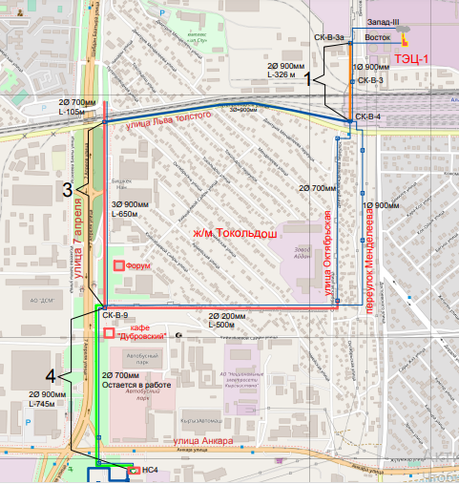
Annex 1. General Layout of “Vostok” network

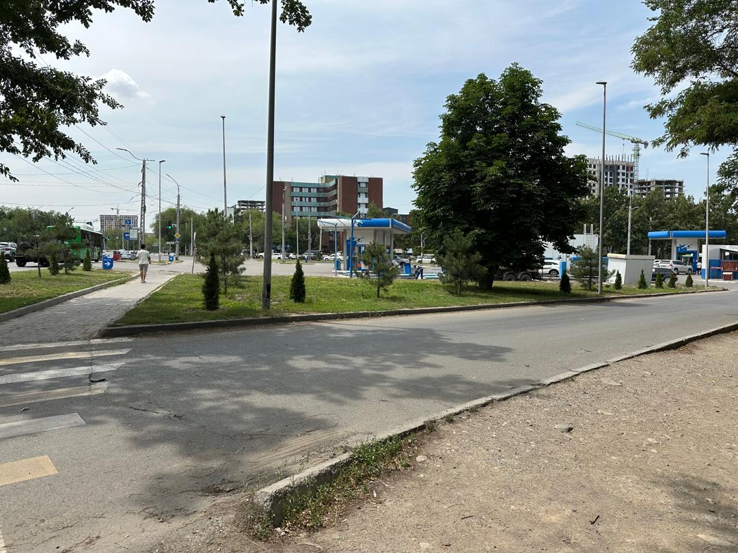
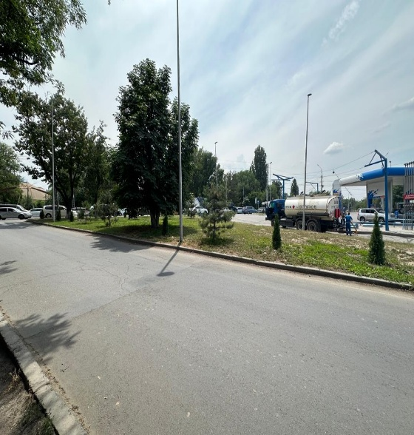
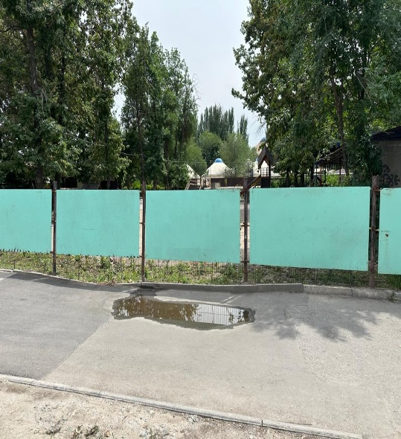
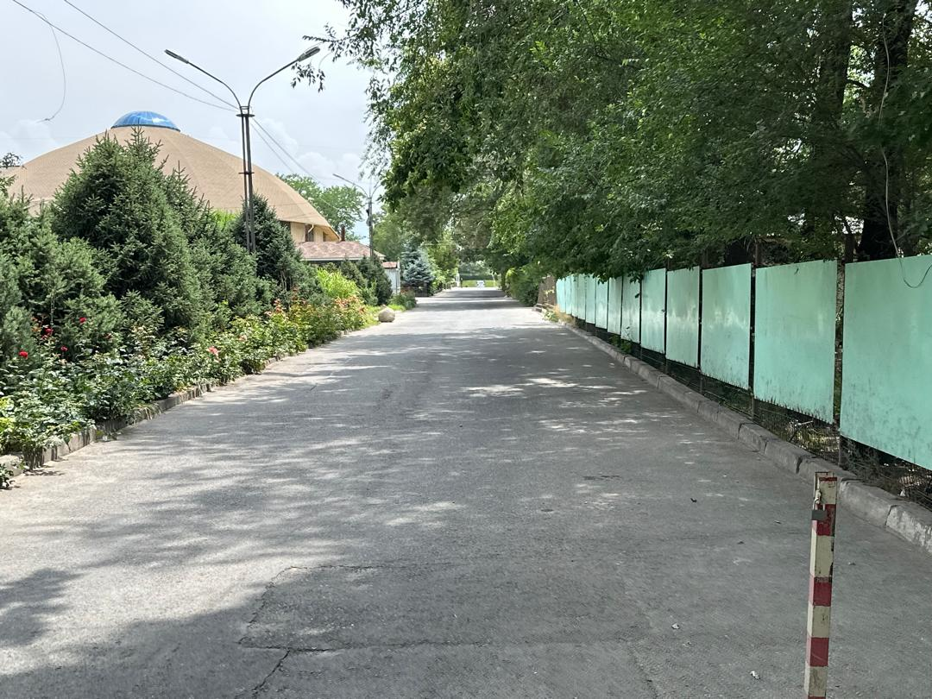
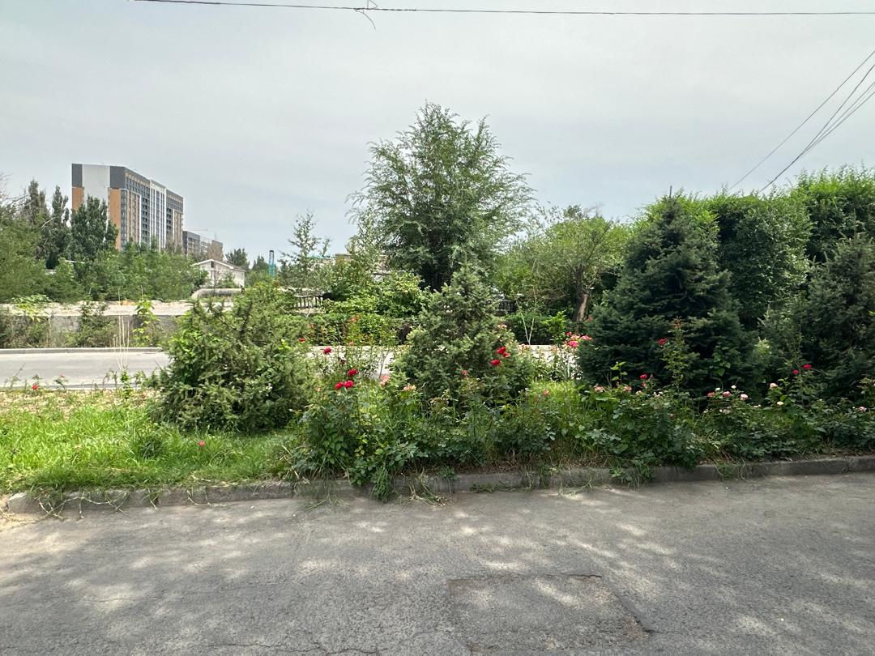
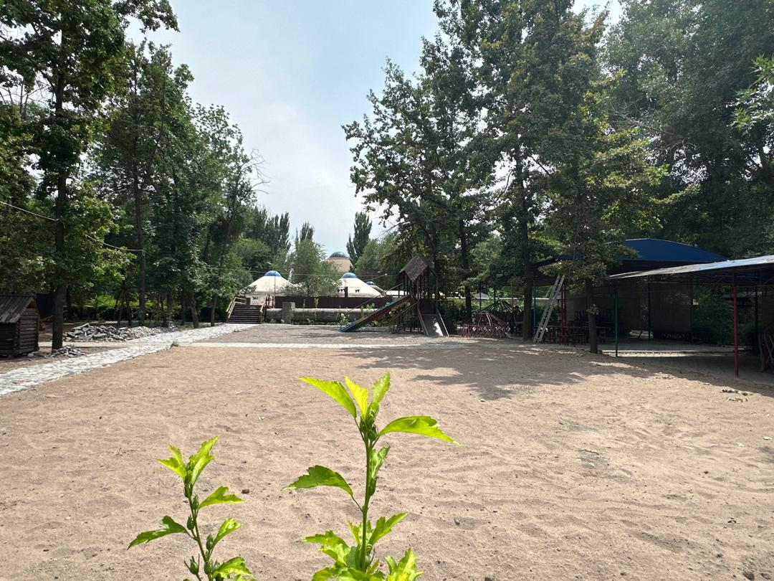
Annex 2. Facilities recovered by the Contractor

Annex 3. Letter of Guarantee

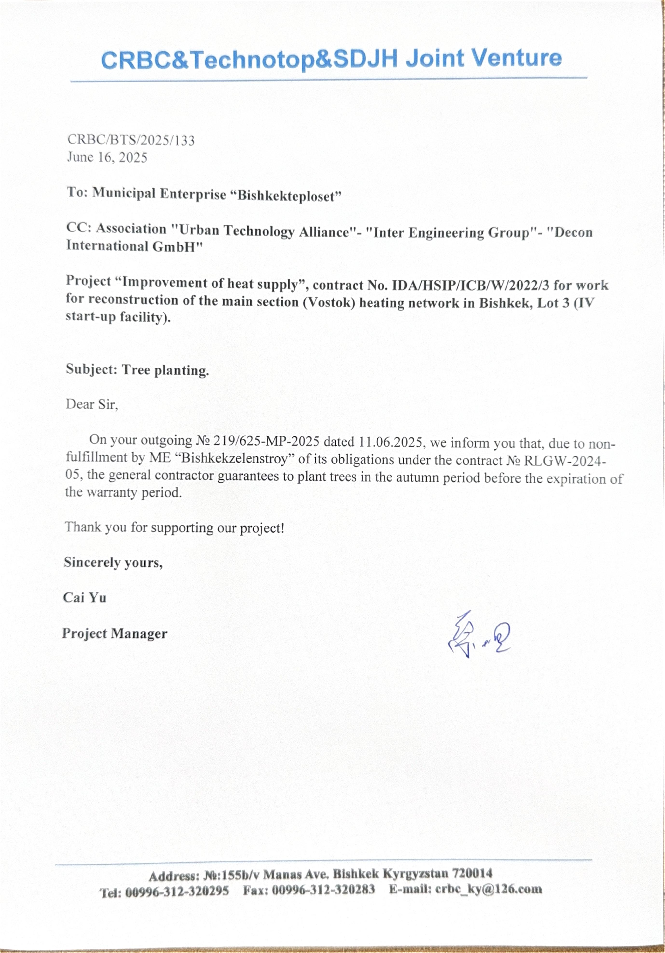

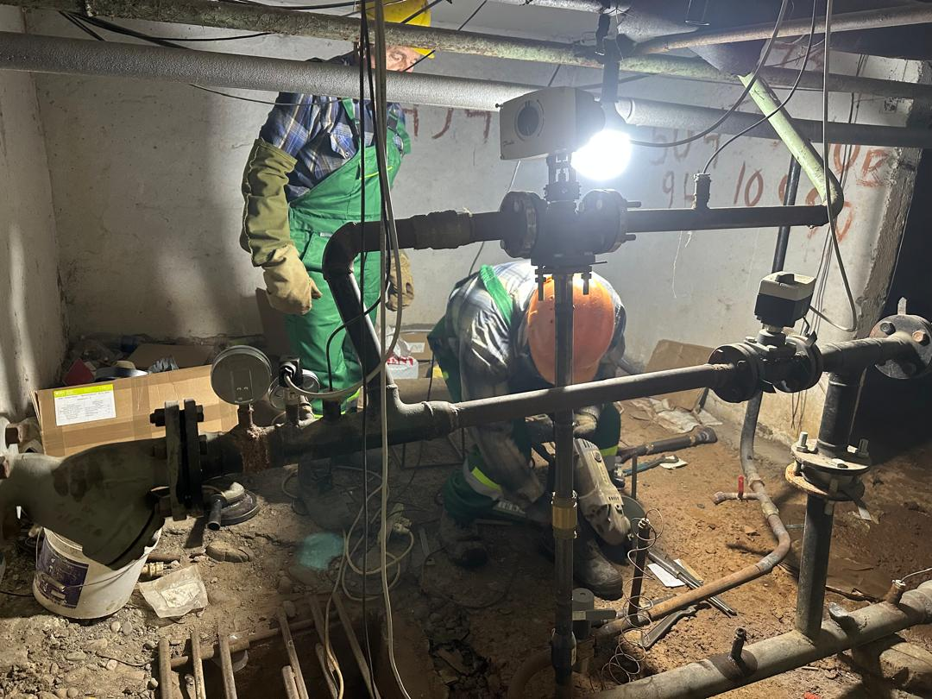
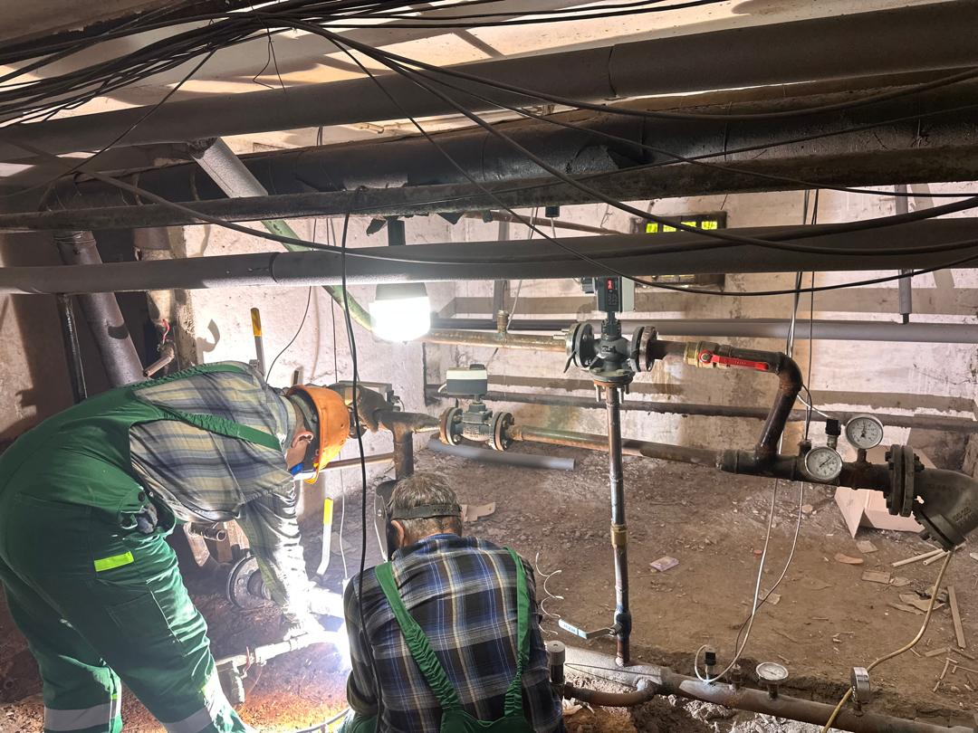
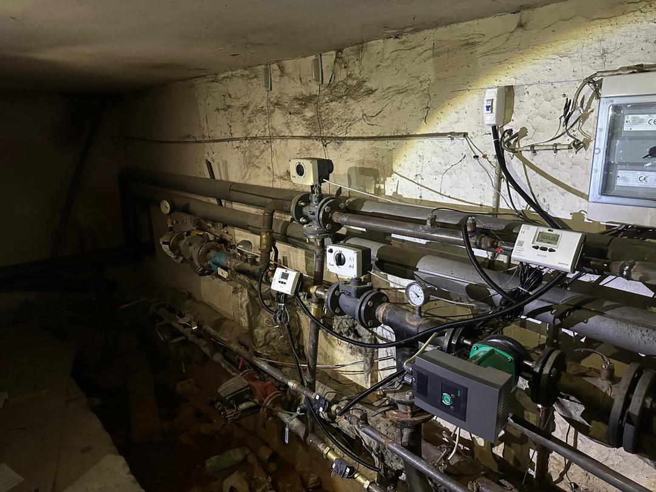
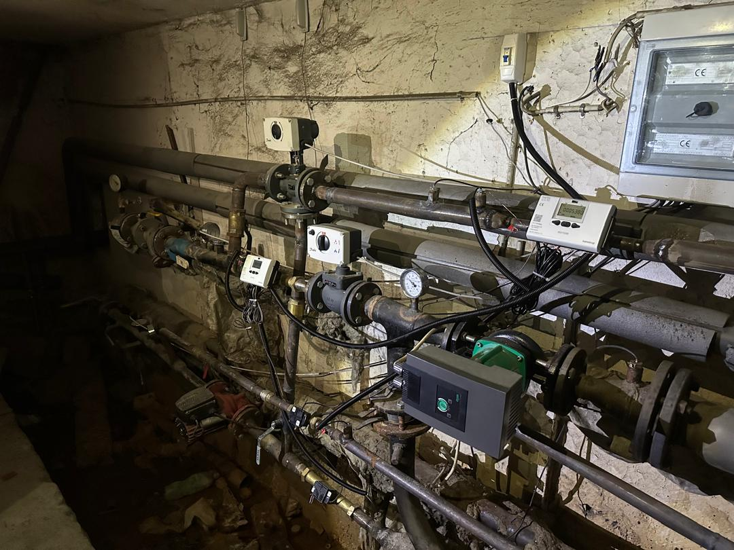
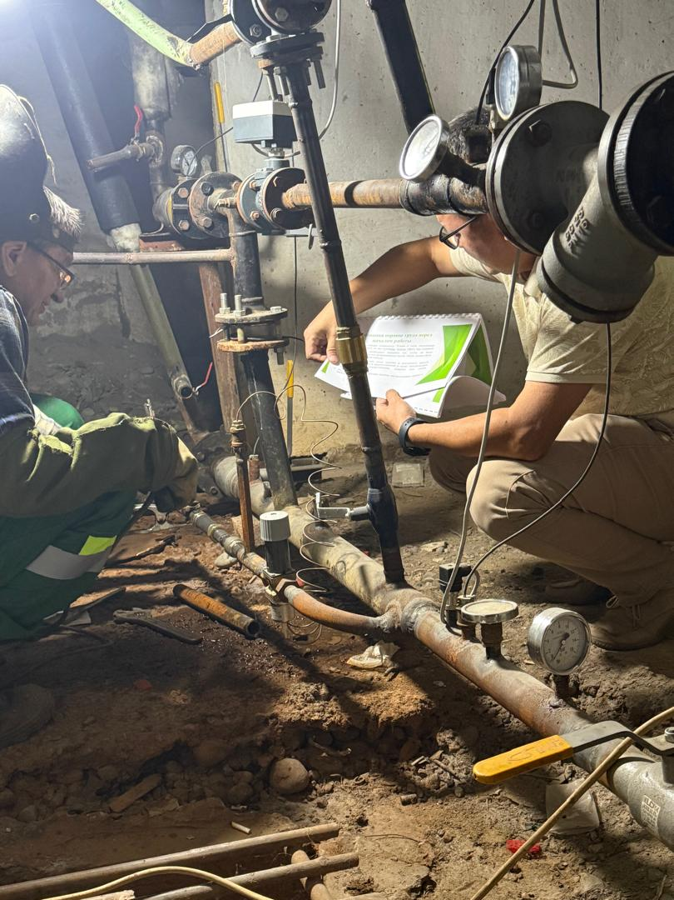
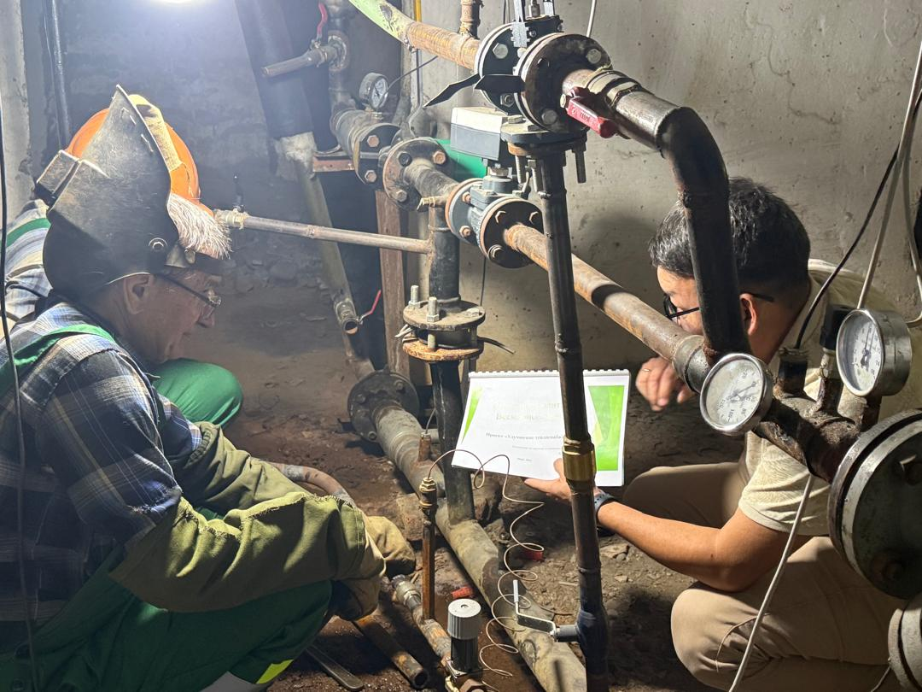
Annex 4. Training

Bishkekteploset became a municipal enterprise on August 8, 2024. It occurred after registration in Justice authorities with organizational and legal form “municipal enterprise”. Prior to that, the enterprise was a branch of OJSC “Electric Power Plants”.
http://teploseti.kg/content/page/76
http://teploseti.kg/content/page/76
http://teploseti.kg/content/page/76
http://teploseti.kg/content/page/76
http://teploseti.kg/content/page/76
Data as of 10.07.2025.
http://teploseti.kg/content/page/76

